Kubernetes:

* **K8S is container orchestration tool which helps in deploying, scaling and managing container based applications**
* Kubernetes also known as K8s was built by Google is one of the most popular container orchestration tool
* So we now have our application packaged into a docker container. But what next? How do you run it in production?
* What if your application relies on other containers such as database or messaging services or other backend services?
* What if the number of users increase and you need to scale your application? You would also like to scale down when the load decreases.
* All these activities are managed by orchestration tool
* The process of automatically deploying and managing containers is known as Container Orchestration
* Kubernetes one of the container orchestration technologies
* There are multiple such technologies available today – Docker has its own tool called Docker Swarm. Kubernetes from Google and Mesos from Apache

Advantages:

* Your application is now highly available as hardware failures do not bring your application down because you have multiple instances of your application running on different nodes
* The user traffic is load balanced across the various containers
* When demand increases, deploy more instances of the application seamlessly and within a matter of second
* When we run out of hardware resources, scale the number of nodes up/down without having to take down the application
* 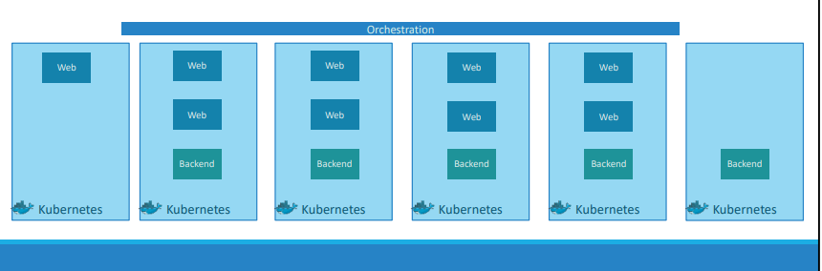

K8S Installation:

* We can install k8s in multiple ways, simple ways are using docker desktop and minikube
* We have light weight version of k8s which is k3s
* For production we can go for microk8s

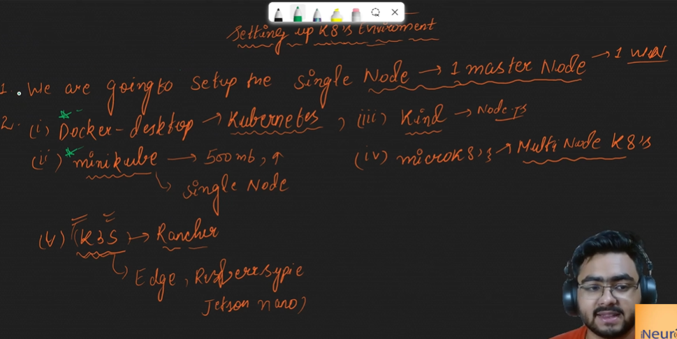

* There are two ways where we can interact with Kubernetes cluster
* Using kubectl -> kubectl is a command line tool which can be used to interact with Kubernetes cluster, we can create, delete pods and create deployments and much more
* Second approach is minikube/kind/microservices
* When we want to define memory and other configs, we can go with second approach
* 
* K8s installation from docker desktop
* 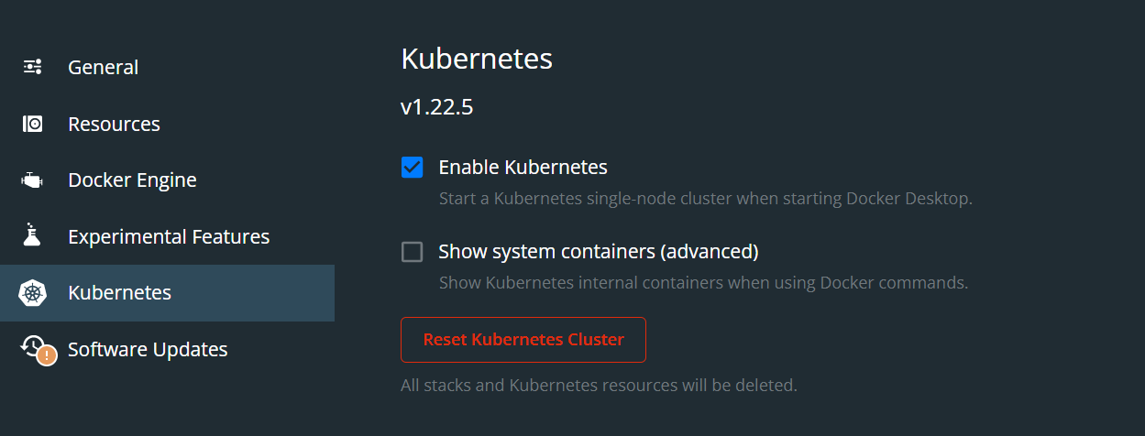
* For minikube refer it’s documentation page

Node:

* A node is a machine – physical or virtual – on which kubernetes is installed
* A node is a worker machine and this is where containers will be launched by Kubernetes
* 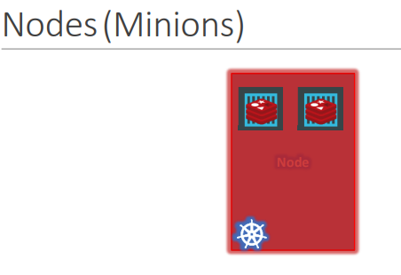

Pod:

* Smallest deployable unit that can be managed by k8s
* Pod contains groups a containers

Cluster:

* A cluster is a set of nodes grouped together. This way even if one node fails you have your application still accessible from the other nodes. Moreover, having multiple nodes helps in sharing load as well
* 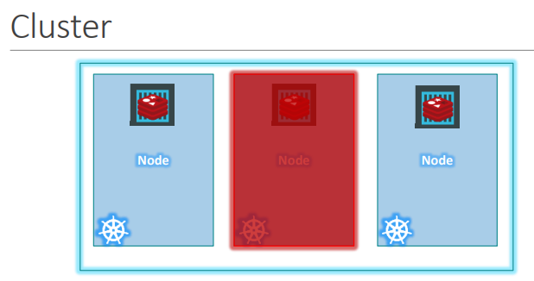

Master:

* 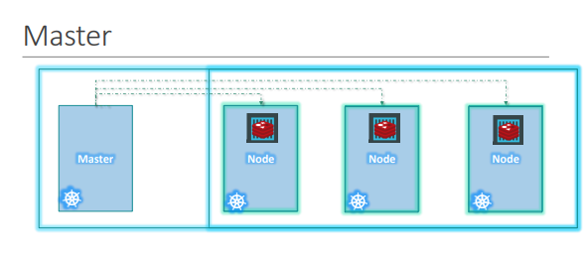
* Now we have a cluster, but who is responsible for managing the cluster? Where is the information about the members of the cluster stored? How are the nodes monitored? When a node fails how do you move the workload of the failed node to another worker node? That’s were the Master comes in.
* The master is another node with Kubernetes installed in it, and is configured as a Master.
* The master manages all the worker node.

Components In Master Node:

* 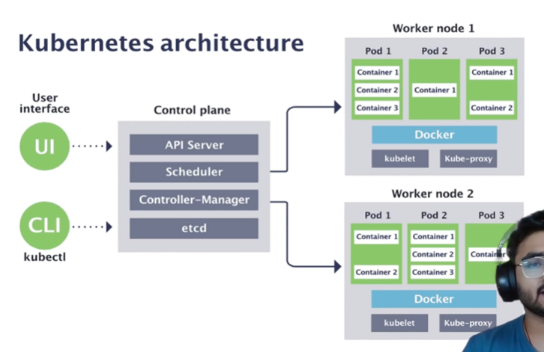
* We can interact with master node/control plane using UI or kubectl
* 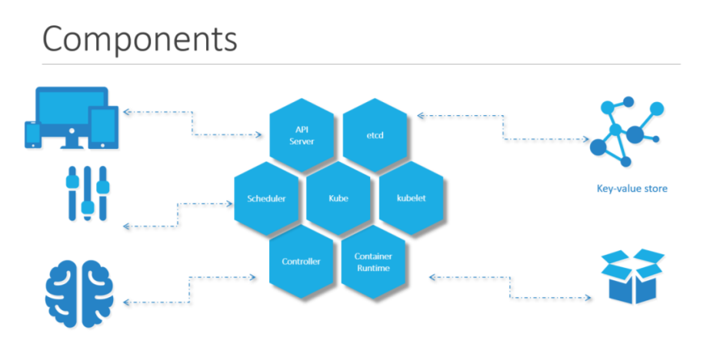
* When you install Kubernetes on a System, you are actually installing the following components. An API Server, An ETCD service, A kubelet service, A Container Runtime, Controllers and Schedulers

API Server:

* It helps in communication from master node to worker node
* The API server acts as the front-end for kubernetes. The users, management devices, Command line interfaces all talk to the API server to interact with the kubernetes cluster

ETCD:

* ETCD is a distributed reliable key-value store used by kubernetes to store all meta-data info related to the cluster.
* Think of it this way, when you have multiple nodes and multiple masters in your cluster, etcd stores all that information on all the nodes in the cluster in a distributed manner.
* ETCD is responsible for implementing locks within the cluster to ensure there are no conflicts between the Masters

SCHEDULER:

* One of the key component of k8s master. It is responsible for distributing workload or containers/pods across multiple nodes
* It looks for newly created pods and assigns them to Nodes

Controller:

* The controllers are the brain behind orchestration.

Node Controller:

* They are responsible for noticing and responding when nodes, containers or endpoints goes down.
* The controllers makes decisions to bring up new containers in such cases

Replication Controller:

* Responsible for maintaining the correct number of pods for every replication controller object in the system

Components Inside k8s Worker Node:

**Container Runtime**

* The is the underlying software that is used to run containers. In our case it happens to be Docker

**KUBELET**:

* And finally kubelet is the agent that runs on each node in the cluster. The agent is responsible for making sure that the containers are running on the nodes as expected

**Kube Proxy**:

* Proxy service which runs on each node and helps in making service available for external host

NameSpaces:

* Namespaces can be termed as virtual sub clusters where all the k8s services are logically separated but can communicate with each other — they can be helpful when different teams or projects share a Kubernetes cluster. Any number of namespaces are supported
* Or
* Namespaces can be considered as houses which have their own set of rules and each of these houses have their own set of resources that they can consume
* we have created objects such as PODs, Deployments and services in our cluster. Whatever we have been doing, We have been doing within a Namespace.
* This Namespace is known as the default Namespace and it is created by k8s during setup
* Kubernetes creates a set of pods and services for its internal purpose and to prevent you from accidentally deleting or modifying the services, Kubernetes creates them under another Namespace created under kube-system
* A third namespace created by kubernetes automatically is called kube-public. This is where resources that should be made available to all users are created.
* If you wanted to use the same cluster for both Dev and Production environment But at the same time isolate the resources between them, you can create a different namespace for each
* It is a technique used to create different-different groups
* 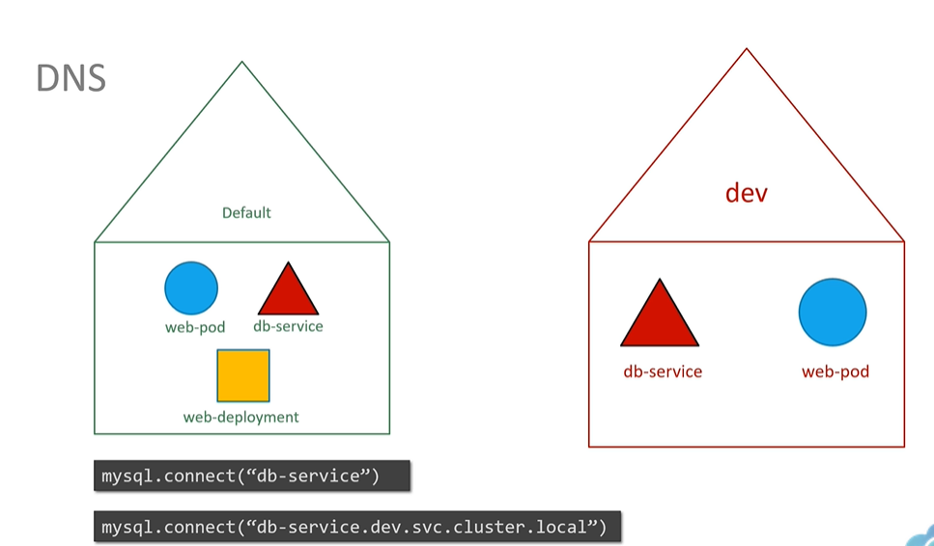
* 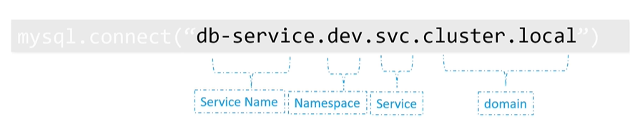

Why use Kubernetes namespaces?

There are many use cases for Kubernetes namespaces, including:

* Allowing teams or projects to exist in their own virtual clusters without fear of impacting each other’s work.
* Enabling the dividing of a cluster’s resources between multiple teams and users via resource quotas.
* Providing an easy method of separating development, testing, and deployment of containerized applications enabling the entire lifecycle to take place on the same cluster.
* 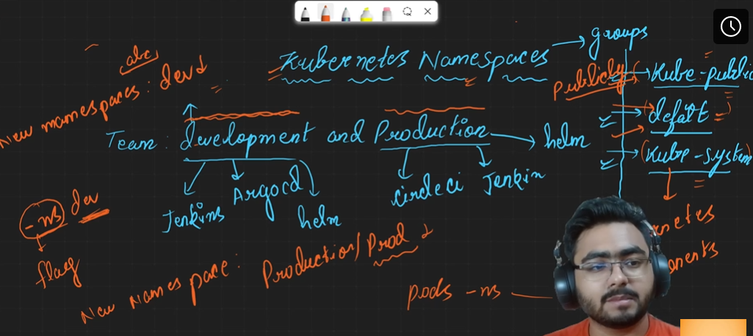
* Kubectl get pods –namespace=kube-system
* Kubectl create -f sample.yaml –namespace=dev
* We can include namespace under metadata section
* 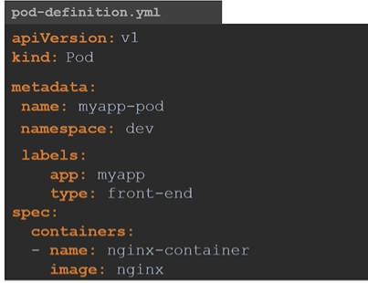
* Create namespace using file
* 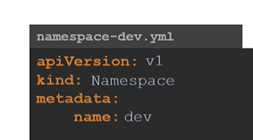
* kubectl get pods --all-namespaces -> to get pods in all namespaces
* To make certain namespace as default -> 
* We can create quotas for each namespace
* 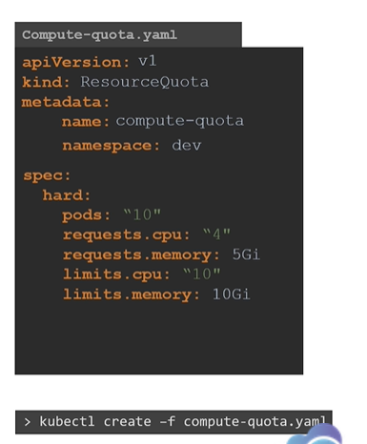
* kubectl create ns atul -> command to create namespace
* kubectl get ns -> to get namespace
* kubectl run nginx --image=nginx -n atul -> to assign namespace to a pod
* kubectl delete ns atul -> to delete namespace

Imperative Commands:

* **Create an NGINX Pod ->** kubectl run nginx --image=nginx
* **Generate POD Manifest YAML file (-o yaml). Don’t create it(–dry-run) ->** kubectl run nginx --image=nginx --dry-run=client -o yaml
* 
* 

Interacting with PODS:

* kubectl get pods -> to get all pods
* kubectl get pods -o wide (To get additional details)
* kubectl get pod <pod_name>
* kubectl describe pod <pod_name>
* kubectl get pod <pod_name> -o yaml > yaml_spec.yaml
* kubectl run nginx --image nginx -> to create a pod
* kubectl edit pod <pod-name> -> command to edit pod properties.

Commands and Arguments:

* In the previous lecture we created a simple docker image that sleeps for a given number of seconds. We named it ubuntu-sleeper and we ran it using the docker command docker run ubuntu-sleeper.
* By default it sleeps for 5 seconds, but you can override it by passing a command line argument.
* We will now create a pod using this image. We start with a blank pod definition template, input the name of the pod and specify the image name.
* When the pod is created, it creates a container from the specified image, and the container sleeps for 5 seconds before exiting
* So to summarize, there are two fields that correspond to two instructions in the Dockerfile.
* The command overrides the entrypoint instruction and the args field overrides the command instruction in the Dockerfile. Remember the command field does not override the CMD instruction in the Dockerfile

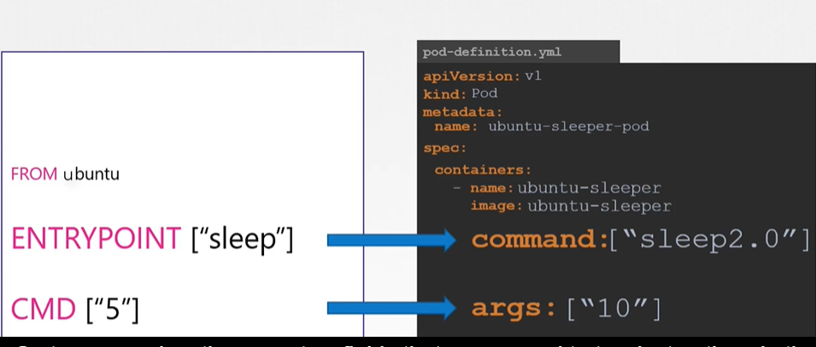

Environment Variables in K8S:

* Let us now see how to pass in an environment variable in Kubernetes.
* Given a pod definition file, which uses the same image as the docker command.
* To set an environment variable, use the ENV property.
* ENV is an array. So every item under the env property starts with a dash, indicating an item in the array.
* Each item has a name and a value property. The name is the name of the environment variable made available within the container and the value is its value
* 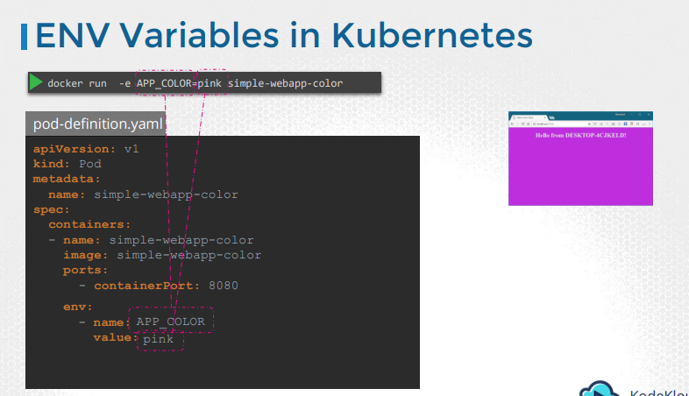
* 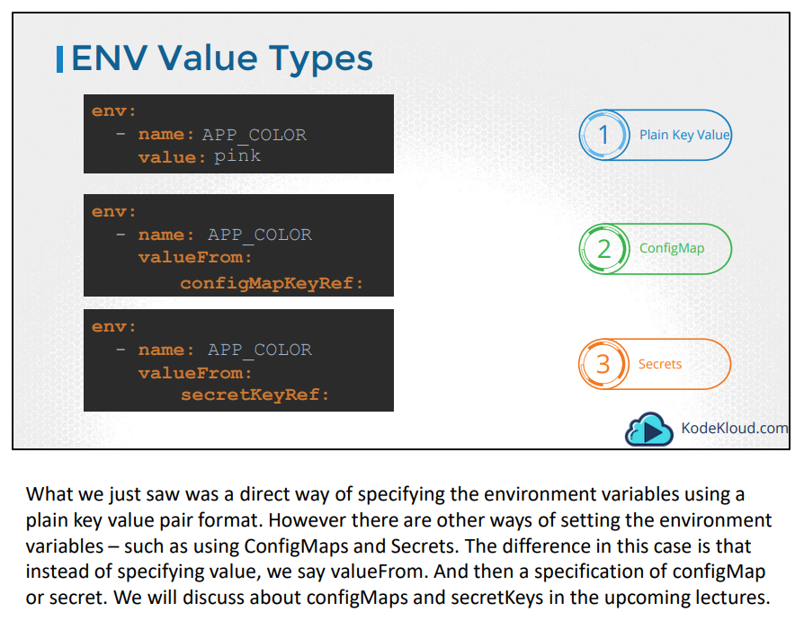

Kubectl:

* The kubectl run command is used to deploy an application on the cluster
* **kubectl run hello-minikube**
* **kubectl cluster-info**
* **kubectl get nodes**

Kubernetes Installation:

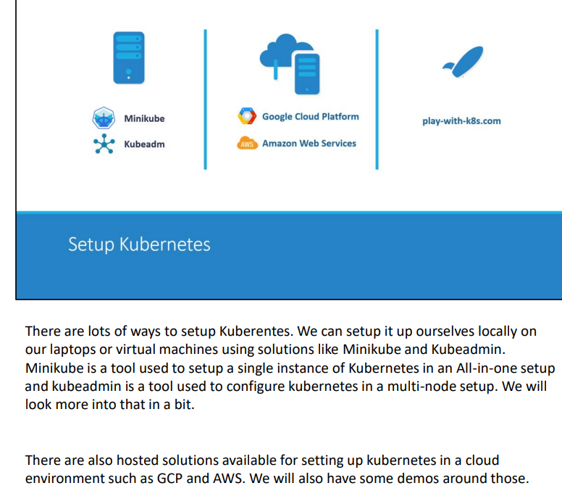

POD:

* As we discussed before, with kubernetes our ultimate aim is to deploy our application in the form of containers on a set of machines that are configured as worker nodes in a cluster
* However, kubernetes does not deploy containers directly on the worker nodes.
* The containers are encapsulated into a Kubernetes object known as PODs. A POD is a single instance of an application.
* A POD is the smallest object, that you can create in Kubernetes
* 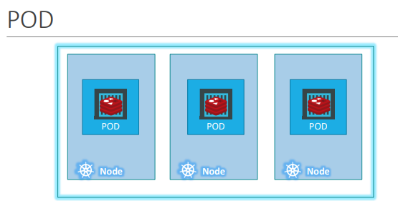
* 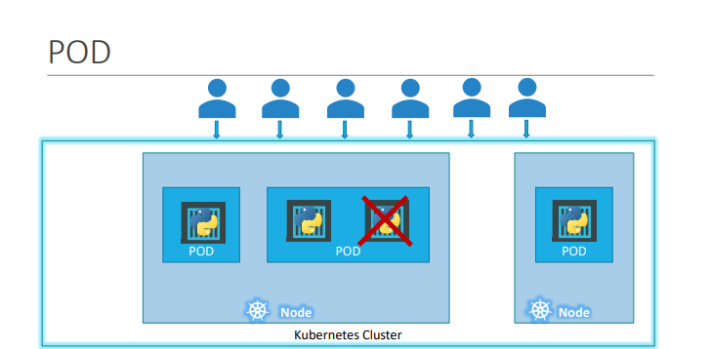
* Here we see the simplest of simplest cases were you have a single node kubernetes cluster with a single instance of your application running in a single docker container encapsulated in a POD.
* What if the number of users accessing your application increase and you need to scale your application?
* You need to add additional instances of your web application to share the load. Now, were would you spin up additional instances? Do we bring up a new container instance within the same POD?
* No! We create a new POD altogether with a new instance of the same application. As you can see we now have two instances of our web application running on two separate PODs on the same kubernetes system or node.
* What if the user base FURTHER increases and your current node has no sufficient capacity? Well THEN you can always deploy additional PODs on a new node in the cluster. You will have a new node added to the cluster to expand the cluster’s physical capacity.
* SO, what I am trying to illustrate in this slide is that, PODs usually have a one-to-one relationship with containers running your application. To scale UP you create new PODs and to scale down you delete PODs. You do not add additional containers to an existing POD to scale your application.
* 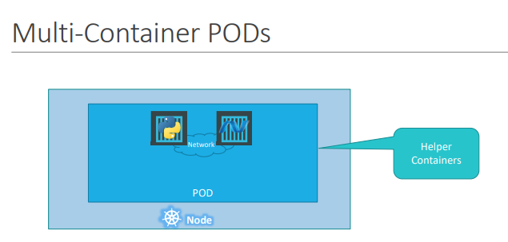
* Now we just said that PODs usually have a one-to-one relationship with the containers, but, are we restricted to having a single container in a single POD? No! A single POD CAN have multiple containers, except for the fact that they are usually not multiple containers of the same kind.
* As we discussed in the previous slide, if our intention was to scale our application, then we would need to create additional PODs.
* But sometimes you might have a scenario were you have a helper container, that might be doing some kind of supporting task for our web application such as processing a user entered data, processing a file uploaded by the user etc. and you want these helper containers to live along side your application container.
* In that case, you CAN have both of these containers part of the same POD, so that when a new application container is created, the helper is also created and when it dies the helper also dies since they are part of the same POD

Create Pod using kubectl:

* kubectl run nginx --image nginx
* kubectl get pods
* kubectl describe pod nginx
* kubectl get pods -o wide

Create Pod using yml:

* 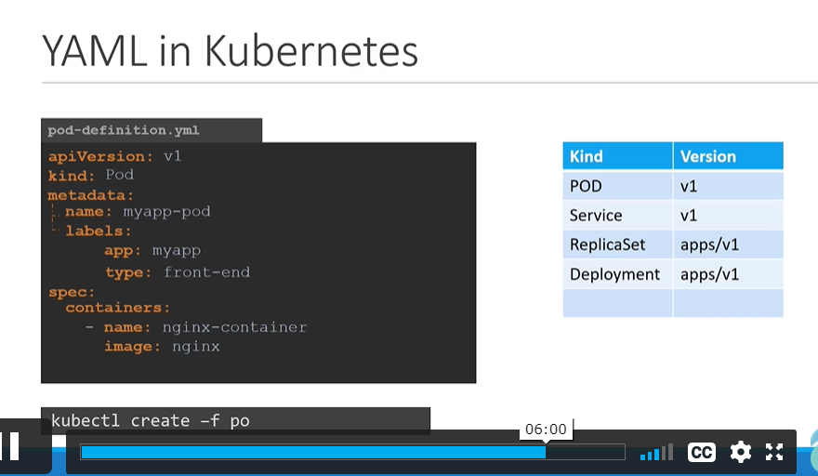
* A kubernetes definition file always contains 4 top level fields. The apiVersion, kind, metadata and spec
* The first one is the apiVersion. This is the version of the kubernetes API we’re using to create the object
* For now since we are working on PODs, we will set the apiVersion as v1
* The kind refers to the type of object we are trying to create, which in this case happens to be a POD. So we will set it as Pod. Some other possible values here could be ReplicaSet or Deployment or Service
* The metadata is data about the object like its name, labels etc
* Container info is mentioned in the spec section
* Once the file is created, run the command kubectl create -f followed by the file name which is pod-definition.yml and kubernetes creates the pod

Replication Controller & Replica Set:

* So what is a replica and why do we need a replication controller?
* Let’s go back to our first scenario were we had a single POD running our application. What if for some reason, our application crashes and the POD fails? Users will no longer be able to access our application.
* To prevent users from losing access to our application, we would like to have more than one instance or POD running at the same time.
* That way if one fails we still have our application running on the other one.
* The replication controller helps us run multiple instances of a single POD in the kubernetes cluster thus providing High Availability.
* So does that mean you can’t use a replication controller if you plan to have a single POD? No! Even if you have a single POD, the replication controller can help by automatically bringing up a new POD when the existing one fails.
* Thus the replication controller ensures that the specified number of PODs are running at all times. Even if it’s just 1 or 100.
* Another reason we need replication controller is to create multiple PODs to share the load across them.
* For example, in this simple scenario we have a single POD serving a set of users. When the number of users increase we deploy additional POD to balance the load across the two pods.
* If the demand further increases and If we were to run out of resources on the first node, we could deploy additional PODs across other nodes in the cluster
* 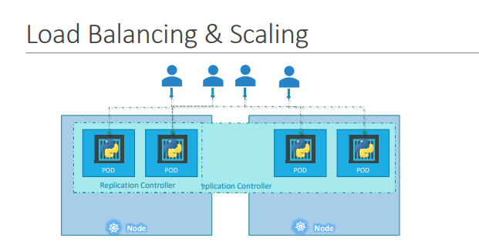
* It’s important to note that there are two similar terms. Replication Controller and Replica Set.
* Both have the same purpose but they are not the same.
* Replication Controller is the older technology that is being replaced by Replica Set. Replica set is the new recommended way to setup replication

apiVersion: apps/v1

kind: ReplicaSet

metadata:

  name: create-replicas

spec:

  selector:

    matchLabels:

      app: replica-app

  replicas: 3

  template:

    metadata:

      name: replica-app

      labels:

        app: replica-app

    spec:

      containers:

        - name: replica-container

          image: nginx

* 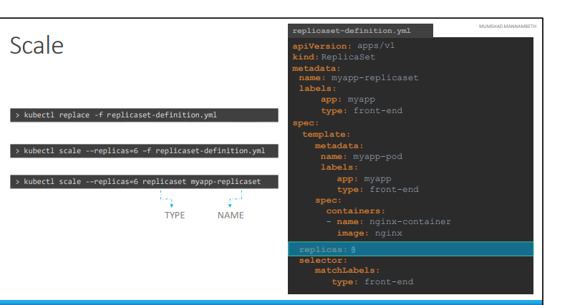
* 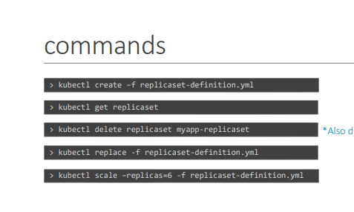

Deployment:

* Say for example you have a web server that needs to be deployed in a production environment. It need not be ONE, but many such instances of the web server running for obvious reasons.
* Secondly, when newer versions of application builds become available on the docker registry, you would like to UPGRADE your docker instances seamlessly
* when you upgrade your instances, you do not want to upgrade all of them at once as we just did. This may impact users accessing our applications, so you may want to upgrade them one after the other. **And that kind of upgrade is known as Rolling Updates**
* **Suppose one of the upgrades you performed resulted in an unexpected error and you are asked to undo the recent update. You would like to be able to rollBACK the changes that were recently carried out**.
* The deployment provides us with capabilities to upgrade the underlying instances seamlessly using rolling updates, undo changes, and pause and resume changes to deployments
* Deployment creates replicaset
* 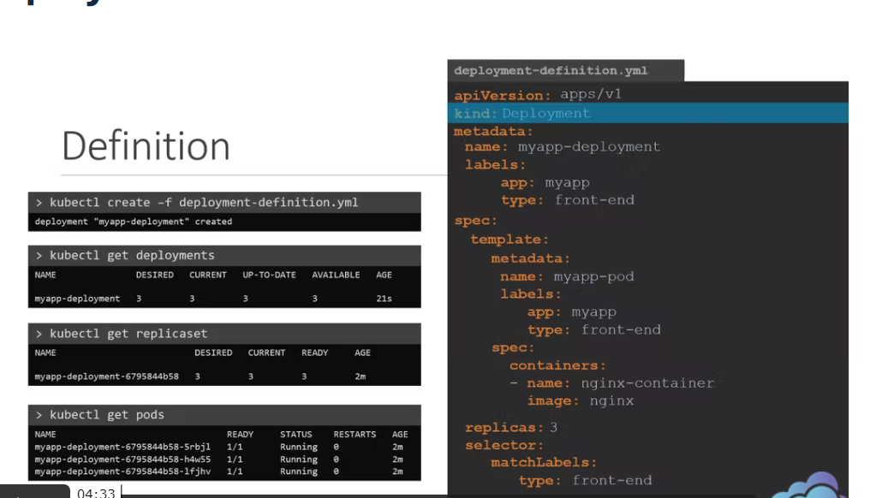

apiVersion: apps/v1

kind: Deployment

metadata:

  name: create-replicas

spec:

  selector:

    matchLabels:

      app: replica-app

  replicas: 3

  template:

    metadata:

      name: replica-app

      labels:

        app: replica-app

    spec:

      containers:

        - name: replica-container

          image: nginx 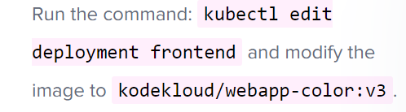

* **Create a deployment ->** kubectl create deployment --image=nginx nginx
* **Generate Deployment with 4 Replicas ->** kubectl create deployment nginx --image=nginx --replicas=4
* You can also scale a deployment using the kubectl scale command. -> kubectl scale deployment nginx --replicas=4
* Create a deployment named webapp using the image kodekloud/webapp-color with 3 replicas 🡪 kubectl create deployment webapp --image=kodekloud/webapp-color --replicas=3
* Create a new pod called custom-nginx using the nginx image and expose it on container port 8080 🡪 kubectl run custom-nginx --image=nginx --port=8080
* Create a new deployment called redis-deploy in the dev-ns namespace with the redis image. It should have 2 replicas 🡪 kubectl create deployment redis-deploy --image=redis --replicas=2 -n dev-ns
* Create a pod called httpd using the image httpd:alpine in the default namespace. Next, create a service of type ClusterIP by the same name (httpd). The target port for the service should be 80 🡪 kubectl run httpd --image=httpd:alpine --port=80 --expose
* 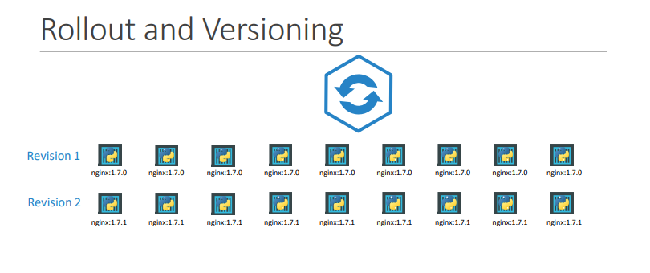
* 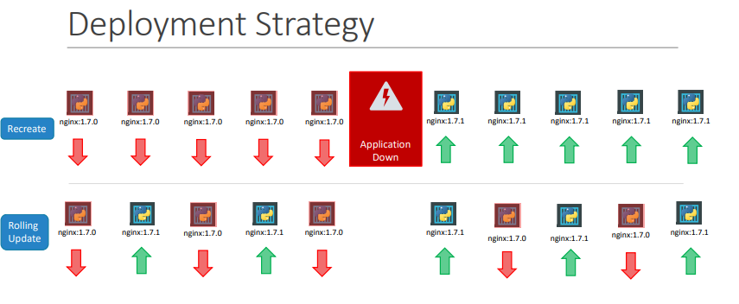 There are two types of deployment strategies. Say for example you have 5 replicas of your web application instance deployed.
* One way to upgrade these to a newer version is to destroy all of these and then create newer versions of application instances.
* Meaning first, destroy the 5 running instances and then deploy 5 new instances of the new application version.
* The problem with this as you can imagine, is that during the period after the older versions are down and before any newer version is up, the application is down and inaccessible to users.
* This strategy is known as the Recreate strategy, and thankfully this is NOT the default deployment strategy.
* The second strategy is where we do not destroy all of them at once
* Instead we take down the older version and bring up a newer version one by one. This way the application never goes down and the upgrade is seamless.
* Remember, if you do not specify a strategy while creating the deployment, it will assume it to be Rolling Update. In other words
* RollingUpdate is the default Deployment Strategy

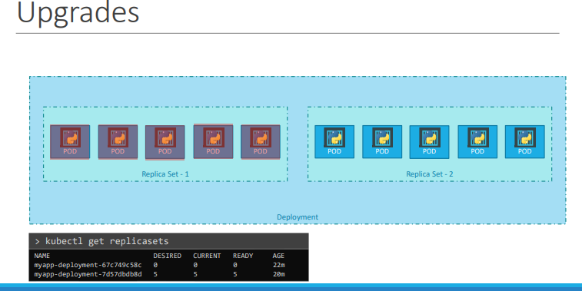

* Let’s look at how a deployment performs an upgrade under the hoods.
* When a new deployment is created, say to deploy 5 replicas, it first creates a Replicaset automatically, which in turn creates the number of PODs required to meet the number of replicas.
* When you upgrade your application as we saw in the previous slide, the kubernetes deployment object creates a NEW replicaset under the hoods and starts deploying the containers there.
* At the same time taking down the PODs in the old replica-set following a RollingUpdate strategy.
* This can be seen when you try to list the replicasets using the kubectl get replicasets command. Here we see the old replicaset with 0 PODs and the new replicaset with 5 PODs.
* 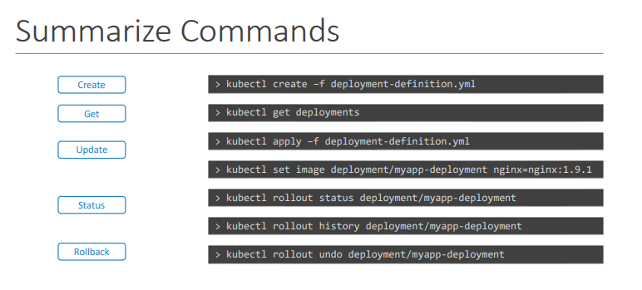

Services:

* Kubernetes Services allows communication between various components within and outside of the application
* For example, our application has groups of PODs running various sections, such as a group for serving front-end load to users, another group running back-end processes, and a third group connecting to an external data source. It is Services that enable connectivity between these groups of PODs
* Services enable the front-end application to be made available to users, it helps communication between back-end and front-end PODs, and helps in establishing connectivity to an external data source.
* 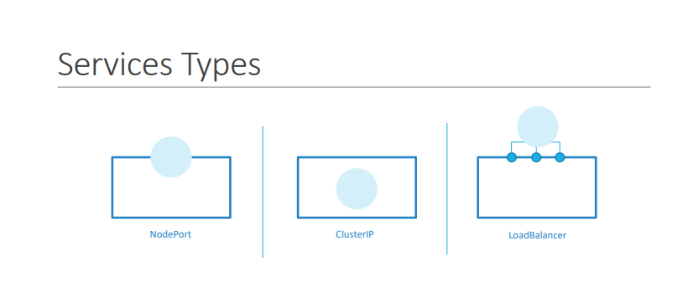
* 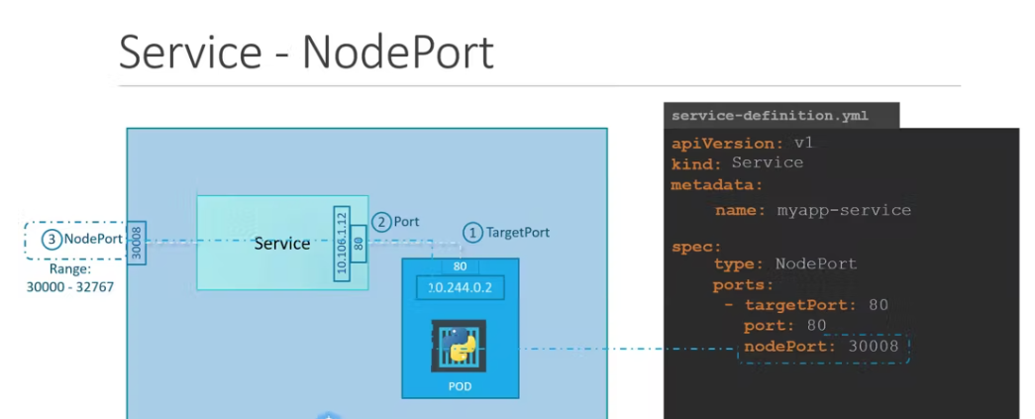
* Let’s take a look at one use case of Services. So far we talked about how PODs communicate with each other through internal networking
* Let’s look at some other aspects of networking in this lecture.
* Let’s start with external communication. So we deployed our POD having a web application running on it.
* How do WE as an external user access the web page?
* First of all, lets look at the existing setup. The Kubernetes Node has an IP address and that is 192.168.1.2.
* My laptop is on the same network as well, so it has an IP address 192.168.1.10. The internal POD network is in the range 10.244.0.0 and the POD has an IP 10.244.0.2.
* Clearly, I cannot ping or access the POD at address 10.244.0.2 as its in a separate network. So what are the options to see the webpage?
* First, if we were to SSH into the kubernetes node at 192.168.1.2, from the node, we would be able to access the POD’s webpage by doing a curl or if the node has a GUI, we could fire up a browser and see the webpage in a browser following the address http://10.244.0.2. But this is from inside the kubernetes Node and that’s not what I really want.
* I want to be able to access the web server from my own laptop without having to SSH into the node and simply by accessing the IP of the kubernetes node
* So we need something in the middle to help us map requests to the node from our laptop through the node to the POD running the web container.
* That is where the kubernetes service comes into play. The kubernetes service is an object just like PODs, Replicaset or Deployments that we worked with before
* **One of its use case is to listen to a port on the Node and forward requests on that port to a port on the POD running the web application.**
* This type of service is known as a NodePort service because the service listens to a port on the Node and forwards requests to PODs. There are other kinds of services available which we will now discuss.
* Node port is the one where we will access the webapp

apiVersion: v1

kind: Service

metadata:

name: mysvc

spec:

selector:

name: myapp

type: NodePort

ports:

- protocol: TCP

port: 5000

targetPort: 5000

nodePort: 30080

apiVersion: v1

kind: Pod

metadata:

name: myapp

labels:

name: myapp

spec:

containers:

- name: myapp

image: atulb/basic_flask_image

ports:

- containerPort: 5000

Cluster IP:

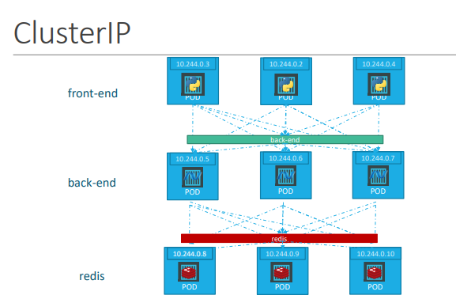

* A full stack web application typically has different kinds of PODs hosting different parts of an application. You may have a number of PODs running a front-end web server, another set of PODs running a backend server, a set of PODs running a keyvalue store like Redis, another set of PODs running a persistent database like MySQL etc.
* The web front-end servers need to connect to the backend-workers and the backend-workers need to connect to database as well as the redis services. So what IS the right way to establish connectivity between these PODs?
* The PODs all have an IP address assigned to them as we can see on the screen.
* But these Ips as we know are not static, these PODs can go down anytime and new PODs are created all the time – and so you CANNOT rely on these IP addresses for internal communication within the application.
* Also what if the first front-end POD at 10.244.0.3 need to connect to a backend service? Which of the 3 would it go to and who makes that decision?
* A kubernetes service can help us group these PODs together and provide a single interface to access the PODs in a group.
* For example a service created for the backend PODs will help group all the backend PODs together and provide a single interface for other PODs to access this service.
* The requests are forwarded to one of the PODs under the service randomly
* Similarly, create additional services for Redis and allow the backend PODs to access the redis system through this service.
* This enables us to easily and effectively deploy a microservices based application on kubernetes cluster. Each layer can now scale or move as required without impacting communication between the various services
* Each service gets an IP and name assigned to it inside the cluster and that is the name that should be used by other PODs to access the service. This type of service is known as ClusterIP.
* 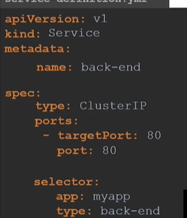

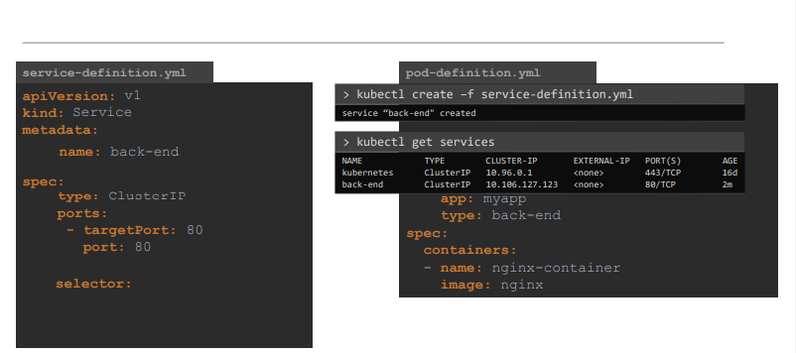

* To create such a service, as always, use a definition file
* In the service definition file , first use the default template which has apiVersion, kind, metadata and spec. The apiVersion is v1 , kind is Service and we will give a name to our service – we will call it back-end.
* Under Specification we have type and ports.
* The type is ClusterIP
* In fact, ClusterIP is the default type, so even if you didn’t specify it, it will automatically assume it to be ClusterIP. Under ports we have a targetPort and port.
* The target port is the port were the back-end is exposed, which in this case is 80. And the port is were the service is exposed. Which is 80 as well. To link the service to a set of PODs, we use selector
* We will refer to the pod-definition file and copy the labels from it and move it under selector. And that should be it.
* We can now create the service using the kubectl create command and then check its status using the kubectl get services command.
* The service can be accessed by other PODs using the ClusterIP or the service name.

Load Balancer:

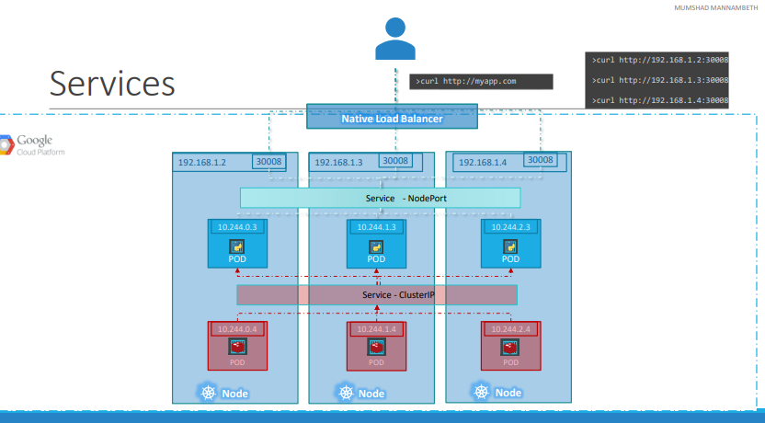

* We have a 3 node cluster with Ips 192.168.1.2,3 and 4.
* Our application is two tier, there is a database service and a front-end web service for users to access the application.
* The default service type – known as ClusterIP – makes a service, such as a redis or database service available internally within the kubernetes cluster for other applications to consume.
* The next tier in my application happens to be a python based web front-end.
* This application connects to the backend using Service created for the redis service.
* To expose the application to the end users, we create another service of type NodePort.
* Creating a service of type NodePort exposes the application on a high end port of the Node and the users can access the application at any IP of my nodes with the port 30008
* Now, what IP do you give your end users to access your application? You cannot give them all three and let them choose one of their own.
* What end users really want is a single URL to access the application
* For this, you will be required to setup a separate Load Balancer VM in your environment.
* In this case I deploy a new VM for load balancer purposes and configure it to forward requests that come to it to any of the Ips of the Kubernetes nodes
* I will then configure my organizations DNS to point to this load balancer when a user hosts <http://myapp.com>.
* Now setting up that load balancer by myself is a tedious task, and I might have to do that in my local or on prem environment.
* However, if I happen to be on a supported CloudPlatform, like Google Cloud Platform, I could leverage the native load balancing functionalities of the cloud platform to set this up.
* Again you don’t have to set that up manually, Kubernetes sets it up for you.
* Kubernetes has built-in integration with supported cloud platforms.
* 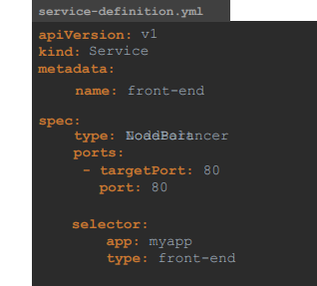

Config Maps:

* In the previous lecture we saw how to define environment variables in a pod definition file
* When you have a lot of pod definition files, it will become difficult to manage the environment data stored within various files
* We can take this information out of the pod definition file and manage it centrally using Configuration Maps
* ConfigMaps are used to pass configuration data in the form of key value pairs in Kubernetes
* When a POD is created, inject the ConfigMap into the POD, so the key value pairs are available as environment variables for the application hosted inside the container in the POD
* So there are two phases involved in configuring ConfigMaps. First create the ConfigMaps and second Inject them into the POD
* 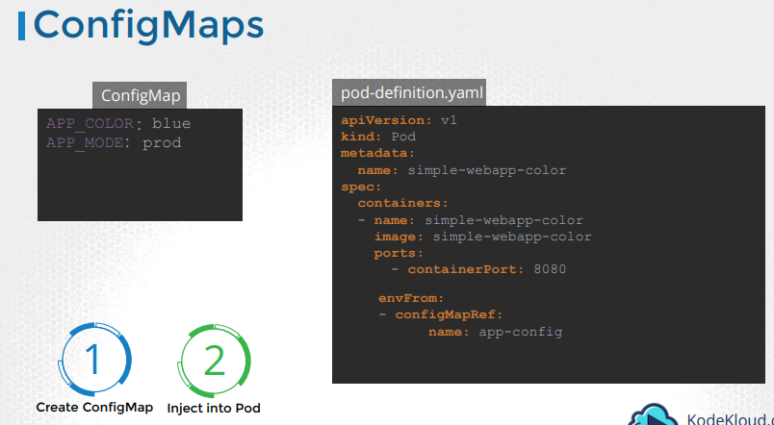
* 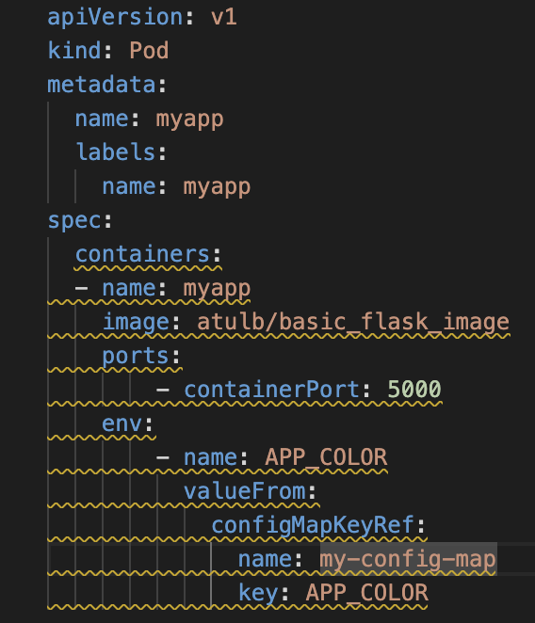 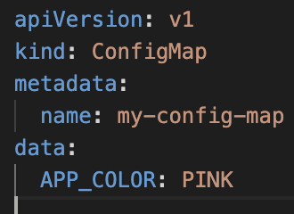
* Just like any other Kubernetes objects, there are two ways of creating a ConfigMap
* The imperative way - without using a ConfigMap definition file and the Declarative way by using a ConfigMap Definition file
* 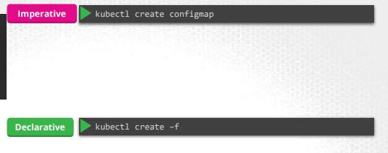

Imperative Way:

* 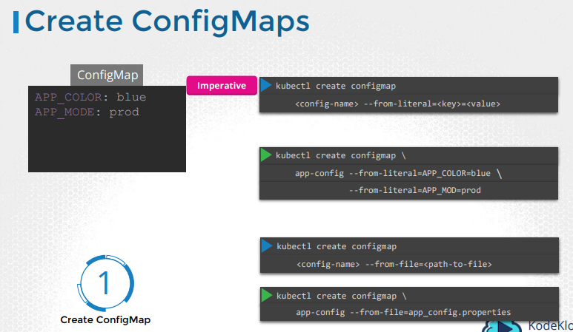

Declarative Way:

* 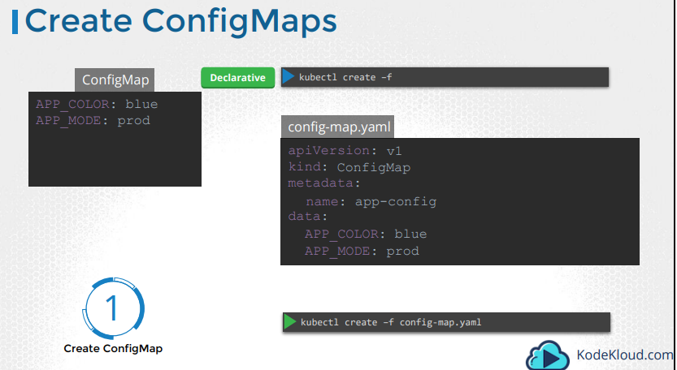

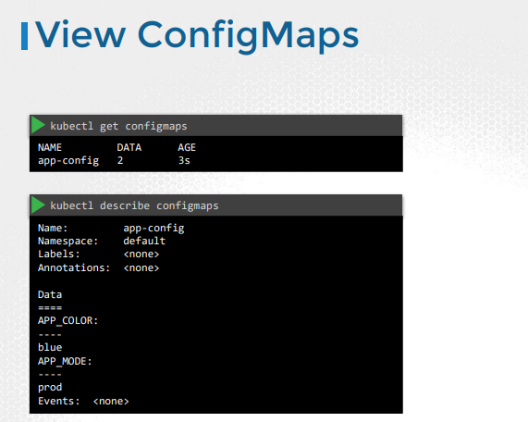

* To view the configmaps, run the kubectl get configmaps command. This lists the newly created configmap named app-config.
* The describe configmaps command lists the configuration data as well under the Data section.

Injecting Config Maps:

* Now that we have the configmap created let us proceed with Step 2 – Configuring it with a POD. Here I have a simple pod definition file that runs my application simple web application
* To inject an environment variable, add a new property to the container called envFrom.
* The envFrom property is a list, so we can pass as many environment variables as required
* 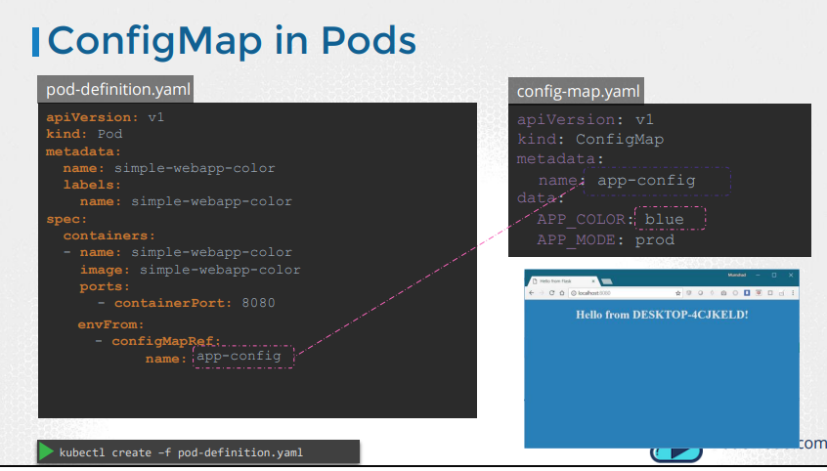
* What we just saw was using configMaps to inject environment variables
* There are other ways to inject configuration data into PODs
* You can inject a single environment variable or inject the whole configuration data as files in a volume
* 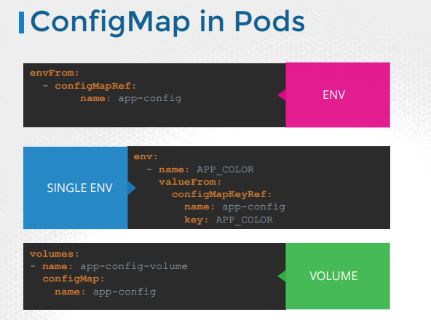

Secrets:

* 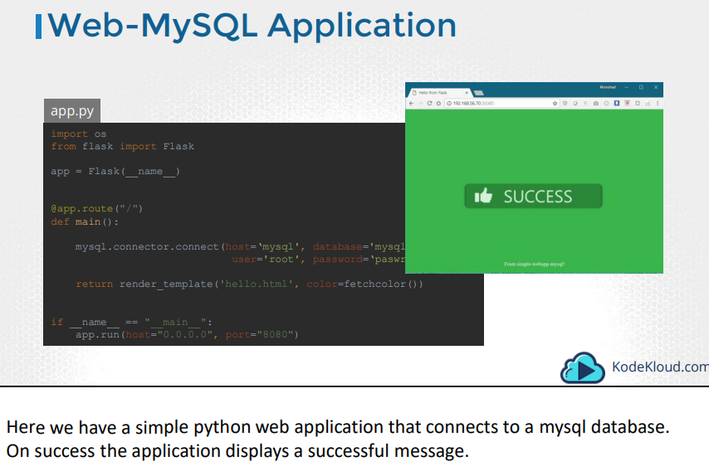
* If you look closely into the code, you will see the hostname, username and password hardcoded. This is of-course not a good idea
* As we learned in the previous lecture, one option would be to move these values into a configMap
* The configMap stores configuration data in plain text, so while it would be OK to move the hostname and username into a configMap, it is definitely not the right place to store a password
* 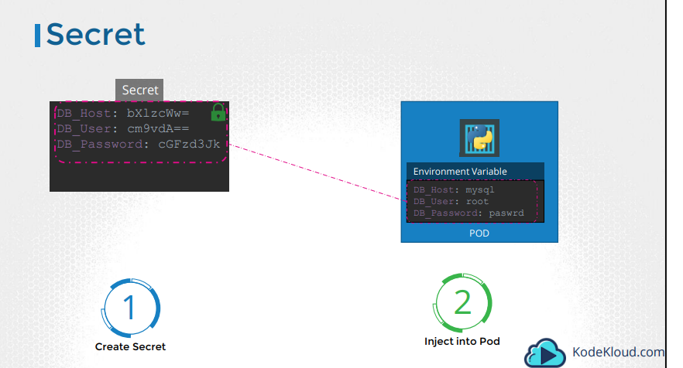
* This is were secrets come in
* Secrets are used to store sensitive information, like passwords or keys
* They are similar to configMaps, except that they are stored in an encoded or hashed format
* As with configMaps, there are two steps involved in working with Secrets. First, create the secret and second inject it into Pod
* There are two ways of creating a secret. The imperative way - without using a Secret definition file and the Declarative way by using a Secret Definition file
* With the Imperative method you can directly specify the key value pairs in the command line itself
* To create a secret of the given values, run the kubectl create secret generic command
* 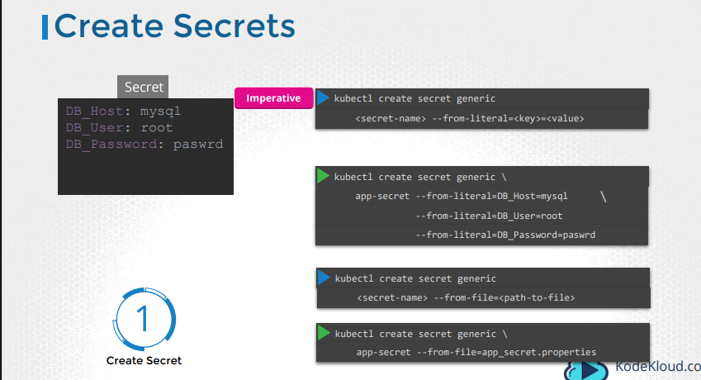
* The command is followed by the secret name and the option –from-literal
* The from literal option is used to specify the key value pairs in the command itself
* In this example, we are creating a secret by the name app-secret, with a key value pair DB_Host=mysql
* If you wish to add additional key value pairs, simply specify the from literal options multiple times
* However, this could get complicated when you have too many secrets to pass in
* Another way to input the secret data is through a file
* Use the –from-file option to specify a path to the file that contains the required data
* The data from this file is read and stored under the name of the file.

Declarative Way:

* Let us now look at the declarative approach. For this we create a definition file, just like how we did for the ConfigMap.
* The file has apiVersion, kind, metadata and data. The apiVersion is v1, kind is Secret. Under metadata specify the name of the secret. We will call it app-secret. Under data add the secret data in a key-value format
* 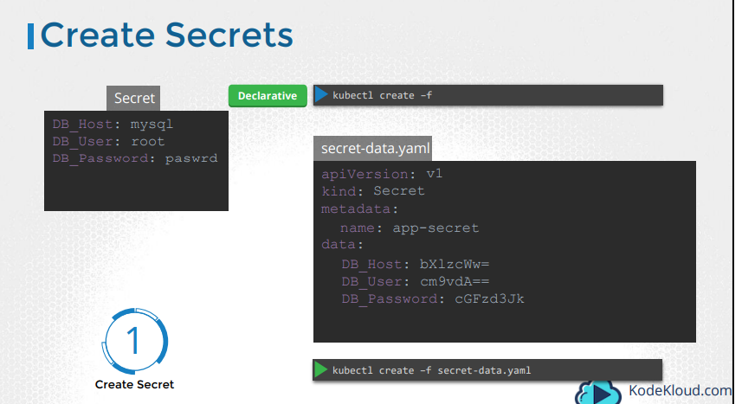
* However, one thing we discussed about secrets was that they are used to store sensitive data and are stored in an encoded format.
* Here we have specified the data in plain text, which is not very safe
* So, while creating a secret with the declarative approach, you must specify the secret values in a hashed format.
* So you must specify the data in an encoded form like this. But how do you convert the data from plain text to an encoded format?
* 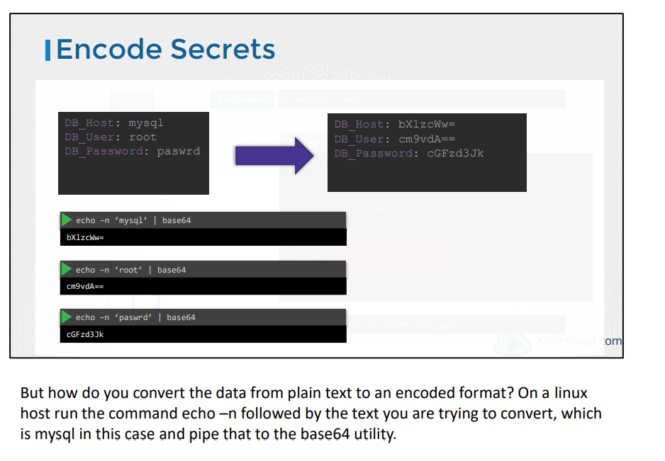
* To view secrets run the kubectl get secrets command. This lists the newly created secret along with another secret previously created by kubernetes for its internal purposes
* To view more information on the newly created secret, run the kubectl describe secret command. This shows the attributes in the secret, but hides the value themselves
* To view the values as well, run the kubectl get secret command with the output displayed in a YAML format using the –o option. You can now see the hashed values as well
* 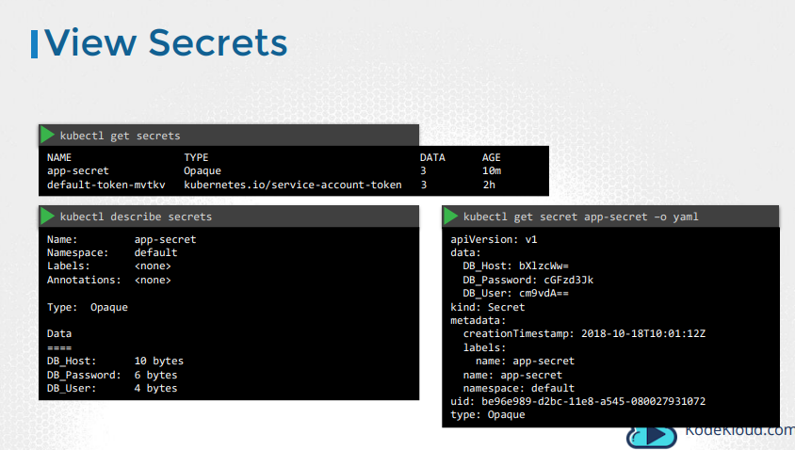
* 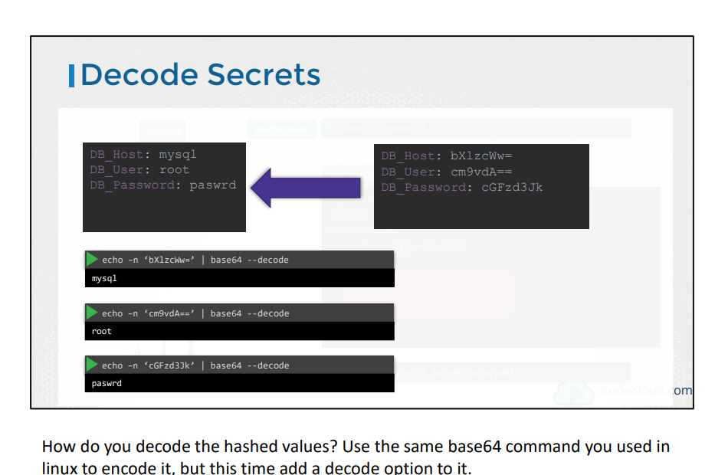

Secrets in Pods:

* 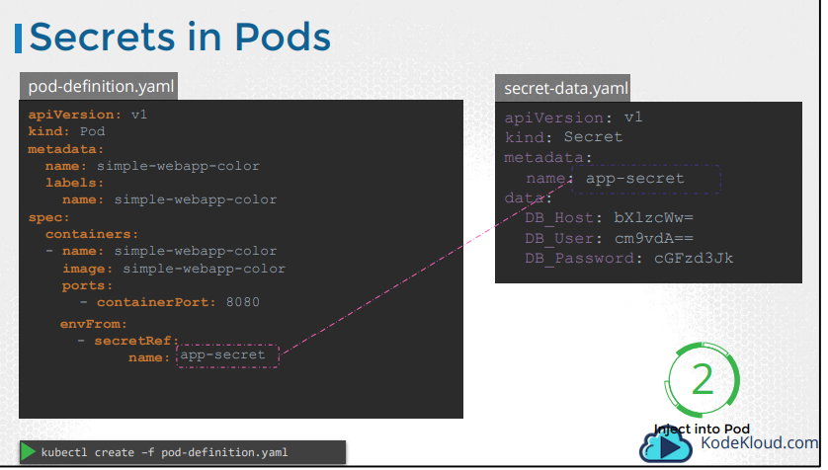
* Now that we have the secret created let us proceed with Step 2 – Configuring it with a POD. Here I have a simple pod definition file that runs my application
* To inject an environment variable, add a new property to the container called envFrom.
* The envFrom property is a list, so we can pass as many environment variables as required
* Each item in the list corresponds to a Secret item
* Specify the name of the secret we created earlier. Creating the POD definition file now makes the data in the secret available as environment variables for the application
* 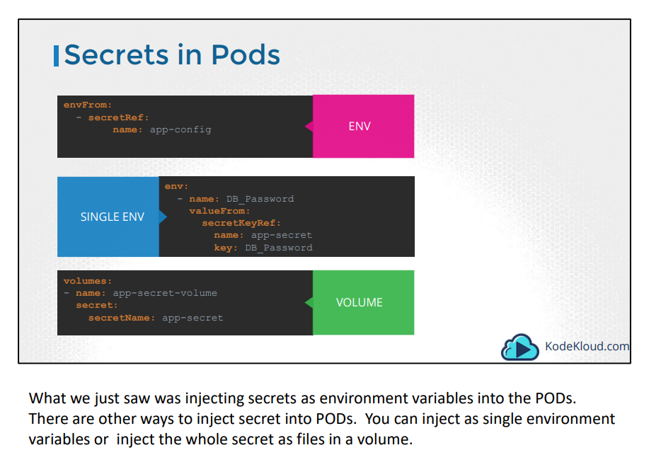
* 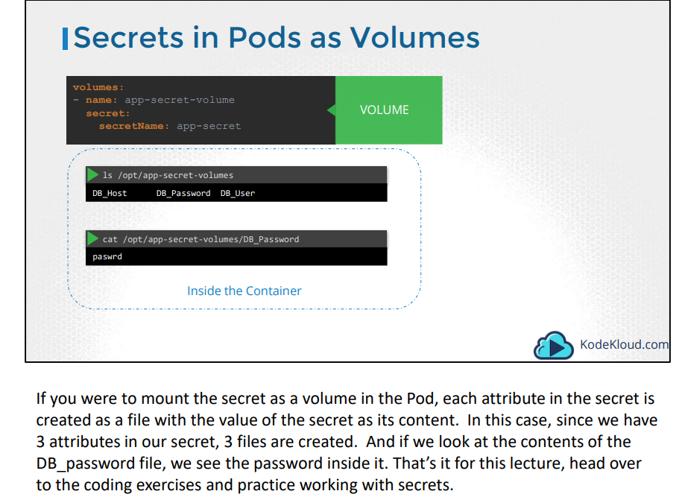

Security in Docker:

* 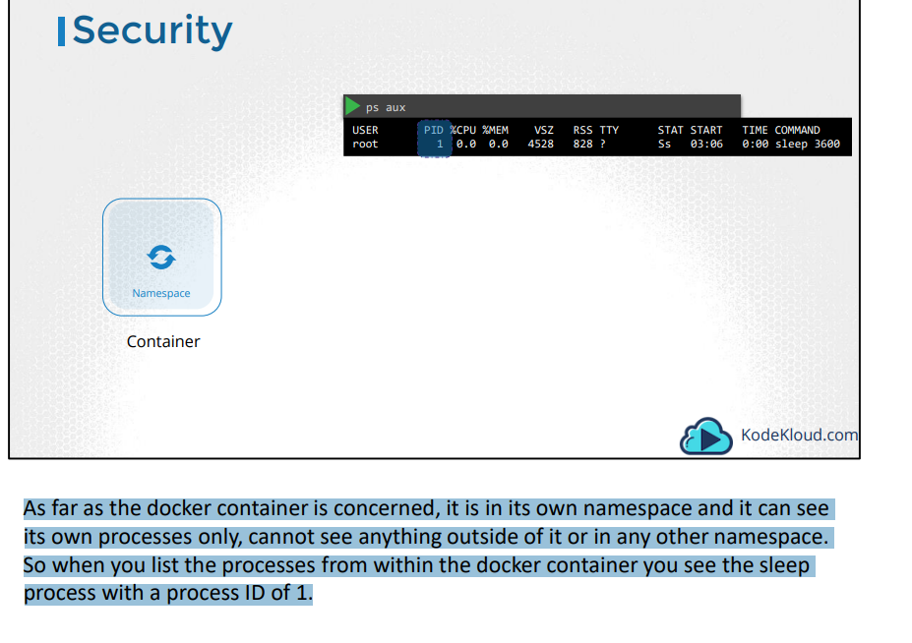
* 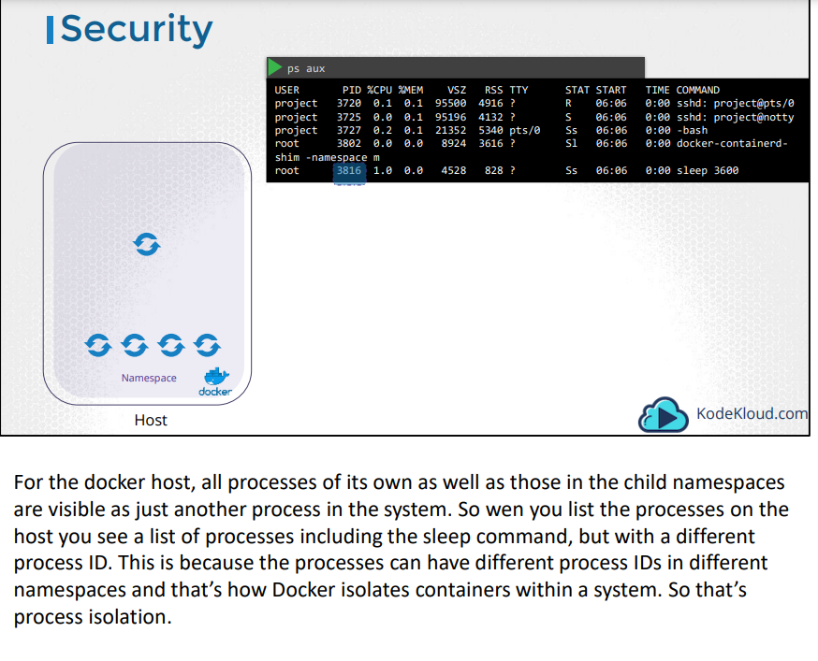

Security Users:

* Let us now look at users in context of security.
* The docker host has a set of users, a root user as well as a number of non-root users
* By default docker runs processes within containers as the root user. This can be seen in the output of the commands
* 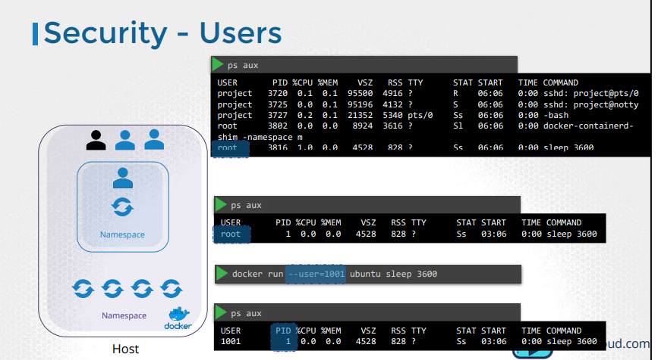
* Both within the container and outside the container on the host, the process is run as the root user
* Now if you do not want the process within the container to run as the root user, you may set the user using the user option with the docker run command and specify the new user ID.
* You will see that the process now runs with the new user id.
* 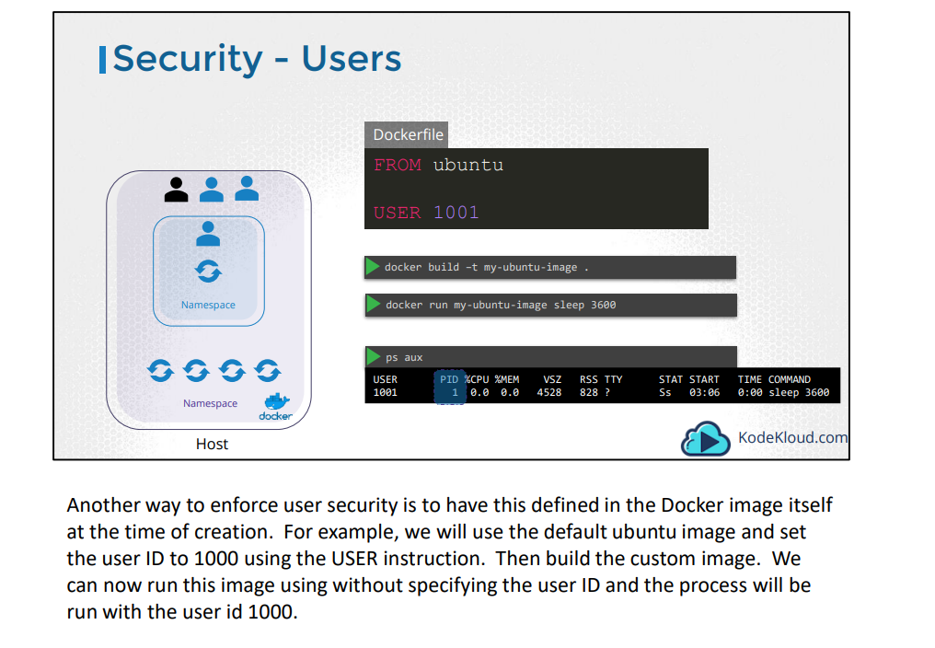
* Is the root user within the container the same as the root user on the host?
* By default Docker runs a container with a limited set of capabilities.
* And so the processes running within the container do not have the privileges to say, reboot the host or perform operations that can disrupt the host or other containers running on the same host
* In case you wish to override this behavior and enable all privileges to the container use the privileged flag
* 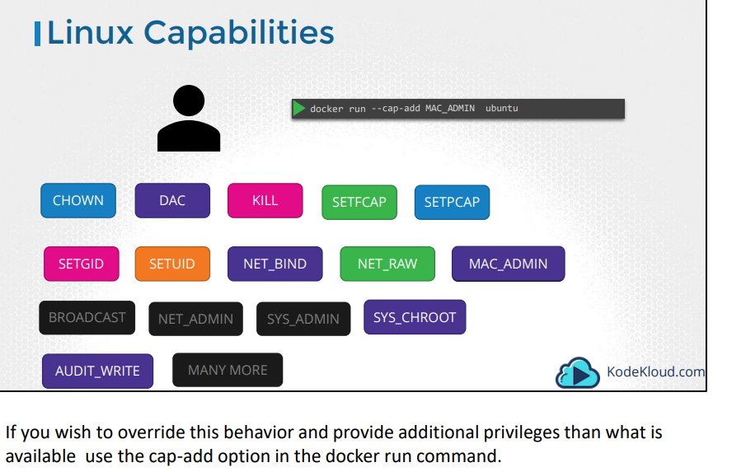
* 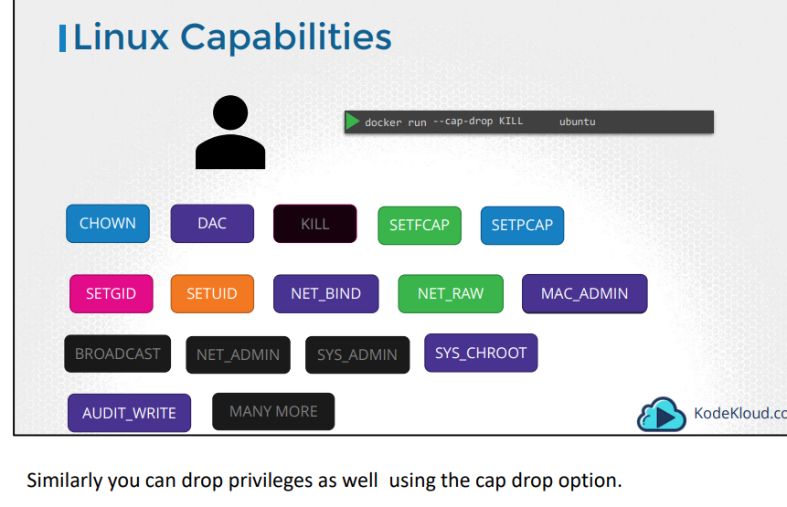
* 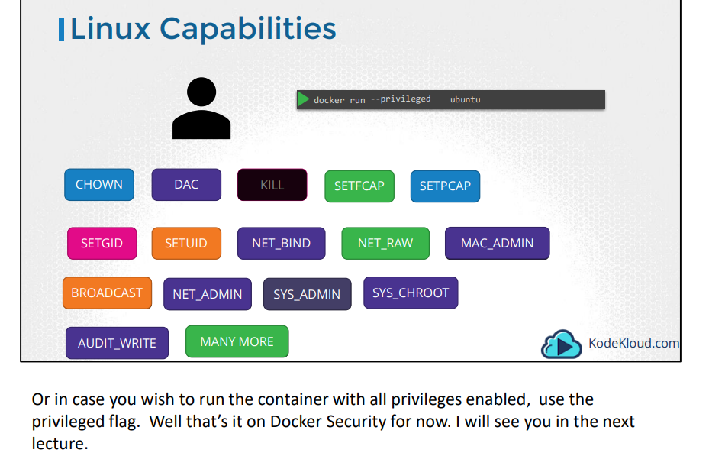

K8S Security:

* As you know already, in Kubernetes containers are encapsulated in PODs. You may chose to configure the security settings at a container level or at a POD level
* If you configure it at a POD level, the settings will carry over to all the containers within the POD. If you configure it at both the POD and the Container, the settings on the container will override the settings on the POD
* To configure security context on the container, add a field called securityContext under the spec section of the pod. Use the runAsUser option to set the user ID for the POD
* 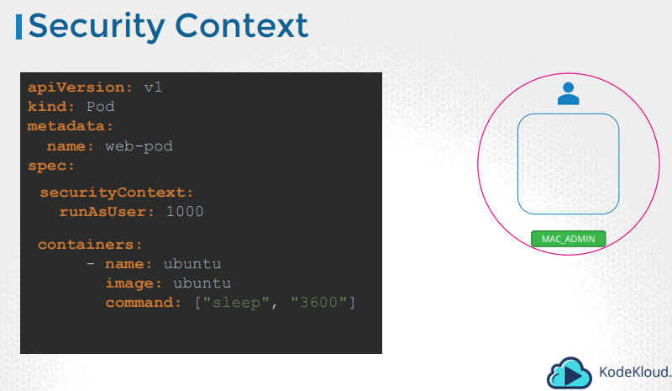
* 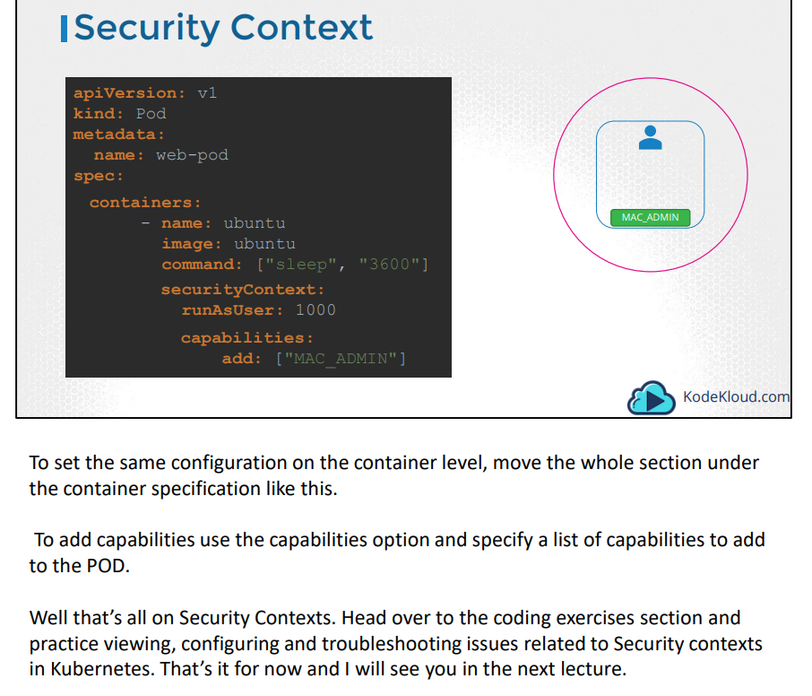

Resource Requirements:

* Let us look at a 3 Node Kubernetes cluster. Each node has a set of CPU, Memory and Disk resources available.
* Every POD consumes a set of resources. In this case 2 CPUs , one Memory and some disk space. Whenever a POD is placed on a Node, it consumes resources available to that node
* 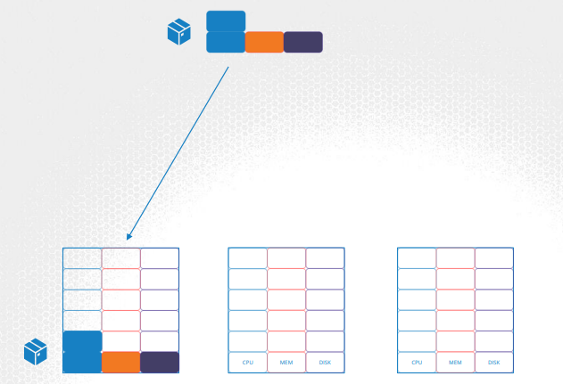
* As we have discussed before, it is the kubernetes scheduler that decides which Node a POD goes to.
* The scheduler takes into consideration, the amount of resources required by a POD and those available on the Nodes. In this case, the scheduler schedules a new POD on Node 2
* 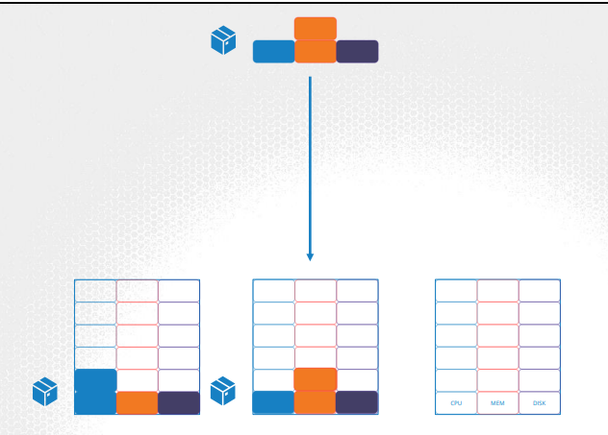
* If the node has no sufficient resources, the scheduler avoids placing the POD on that node, Instead places the POD on one were sufficient resources are available
* 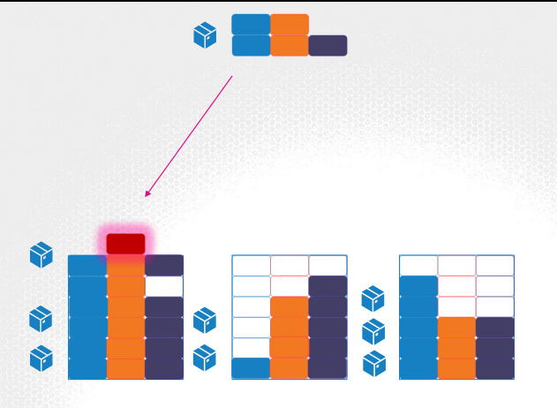
* If there is no sufficient resources available on any of the nodes, Kubernetes holds back scheduling the POD, and you will see the POD in a pending state. If you look at the events, you will see the reason – insufficient cpu
* 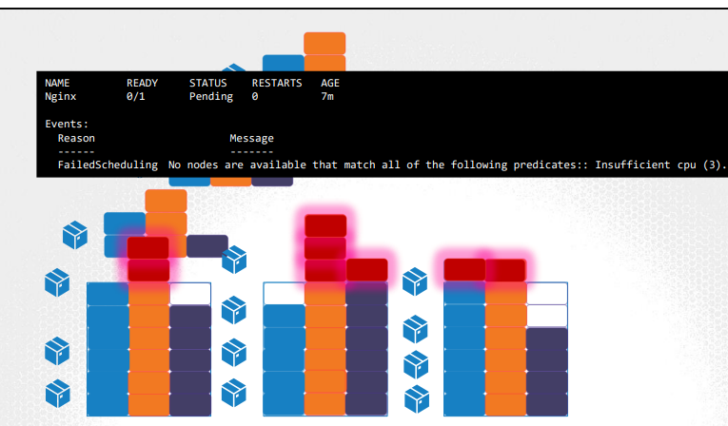
* By default, kubernetes assumes that a POD or a container within a POD requires .5 CPU & 256 Mebibyte of memory. This is known as the resource request for a container
* 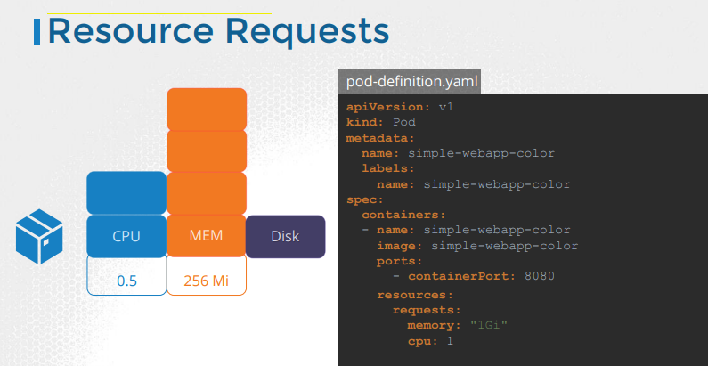
* 0.1 count of CPU is equivalent to 1 vCPU. That’s 1 vCPU in AWS, or 1 Core in GCP or Azure or 1 Hyperthread
* Let’s now look at a container running on a Node. In the Docker world, a docker container has no limit to the resources it can consume on a Node.
* Say a container starts with 1 vCPU on a Node, it can go up and consume as much resource as it requires, suffocating the native processes on the node or other containers of resources.
* However, you can set a limit for the resource usage on these PODs.
* By default Kubernetes sets a limit of 1vCPU to containers. So if you do not specify explicitly, a container will be limited to consume only 1 vCPU from the Node
* The same goes with memory. By default, kubernetes sets a limit of 512 Mebibyte on containers
* So what happens when a pod tries to exceed resources beyond its specified limit.
* In case of the CPU, kubernetes throttles the CPU so that it does not go beyond the specified limit. A container cannot use more CPU resources than its limit.
* However, this is not the case with memory. A container CAN use more memory resources that its limit. So if a pod tries to consume more memory than its limit constantly, the POD will be terminated
* 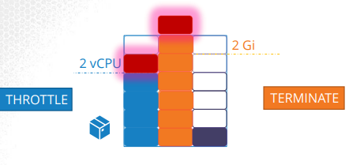
* 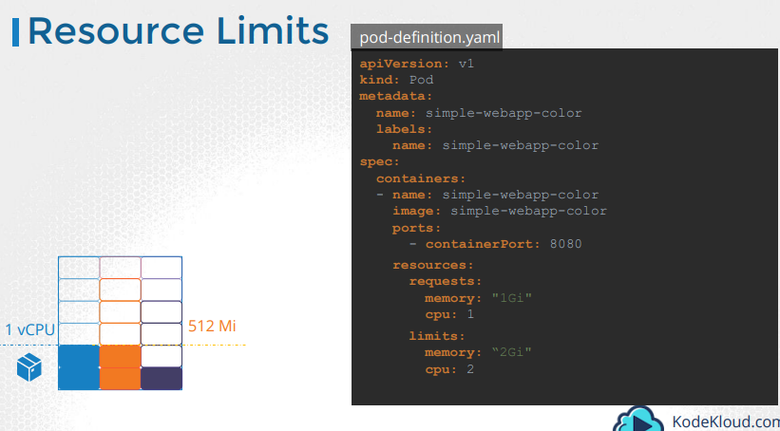

Service Accounts:

* So there are two types of accounts in Kubernetes. A user account and a service account
* the user account is used by humans. And service accounts are used by machines.
* A user account could be for an administrator accessing the cluster to perform administrative tasks, a developer accessing the cluster to deploy applications etc.
* A service account, could be an account used by an application to interact with the kubernetes cluster.
* For example a monitoring application like Prometheus uses a service account to poll the kubernetes API for performance metrics.
* An automated build tool like Jenkins uses service accounts to deploy applications on the kubernetes cluster
* 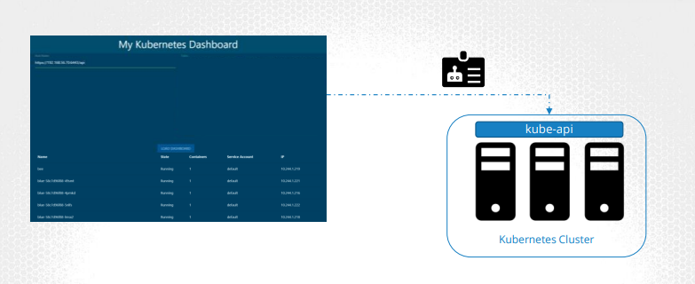
* I have built a simple kubernetes dashboard application named, my-kubernetes-dashboard.
* It’s a simple application built in Python and all that it does when deployed is retrieve the list of PODs on a kubernetes cluster by sending a request to the kubernetes API and display it on a web page.
* In order for my application to query the kubernetes API, it has to be authenticated. For that we use a service account
* To create a service account run the command **kubectl create service account followed by the account name**, which is dashboard-sa in this case.
* To view the service accounts run the kubectl get serviceaccount command. This will list all the service accounts
* 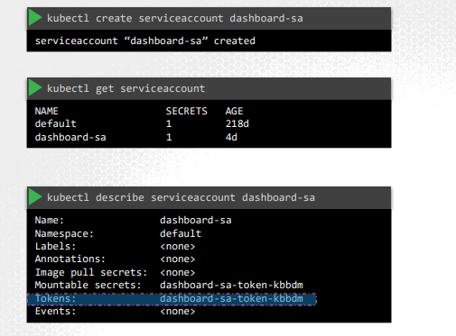
* When the service account is created, it also creates a token automatically
* The service account token is what must be used by the external application while authenticating to the Kubernetes API
* The token, however, is stored as a secret object. In this case its named dashboard-sa-token-kbbdm
* 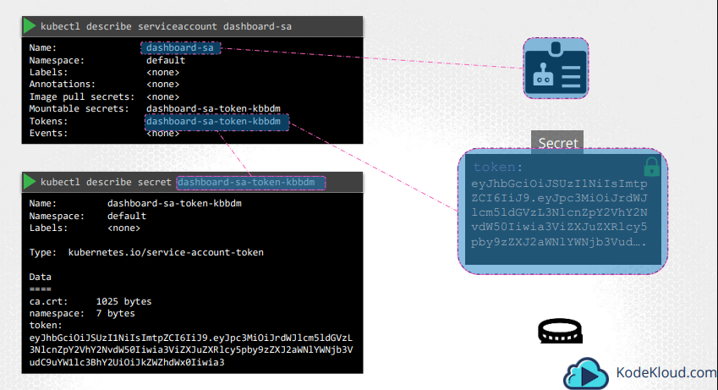
* So when a service account is created, it first creates the service account object and then generates a token for the service account
* It then creates a secret object and stores that token inside the secret object. The secret object is then linked to the service account. To view the token, view the secret object by running the command kubectl describe secret.
* 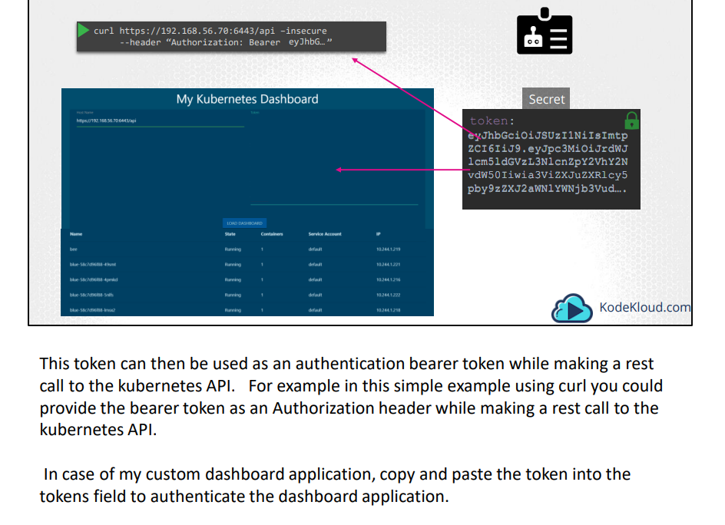
* But what if your third party application is hosted on the kubernetes cluster itself.
* For example, we can have our custom-kubernetes-dashboard or the Prometheus application used to monitor kubernetes, deployed on the kubernetes cluster itself
* In that case, this whole process of exporting the service account token and configuring the third party application to use it can be made simple by automatically mounting the service token secret as a volume inside the POD hosting the third party application
* That way the token to access the kubernetes API is already placed inside the POD and can be easily read by the application
* 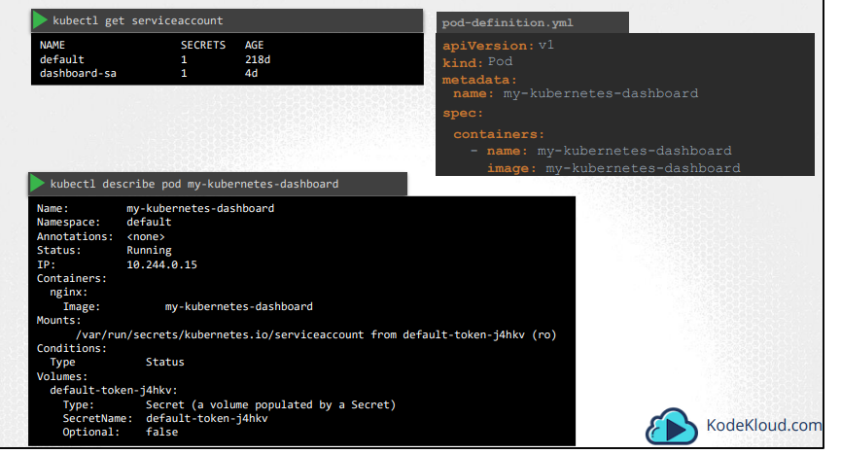
* If you go back and look at the list of service accounts, you will see that there is a default service account that exists already. For every namespace in kubernetes a service account named default is automatically created. Each namespace has its own default service account
* Whenever a POD is created the default service account and its token are automatically mounted to that POD as a volume mount.
* For example, we have a simple pod definition file that creates a POD using my custom kubernetes dashboard image.
* We haven’t specified any secrets or volume mounts. However when the pod is created, if you look at the details of the pod, by running the kubectl describe pod command, you see that a volume is automatically created from the secret named default-token-j4hkv, which is in fact the secret containing the token for the default service account.
* The secret token is mounted at location /var/run/secrets/kubernetes.io/serviceaccount inside the pod. So from inside the pod if you run the ls command
* If you list the contents of the directory inside the pod, you will see the secret mounted as 3 separate files
* 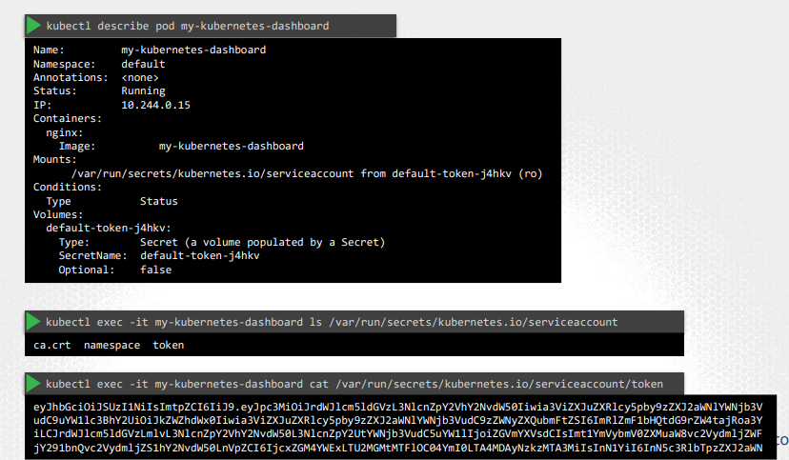
* If you list the contents of the directory inside the pod, you will see the secret mounted as 3 separate files. The one with the actual token is the file named token
* If you’d like to use a different serviceAccount, such as the ones we just created, modify the pod definition file to include a serviceAccount field and specify the name of the new service account
* 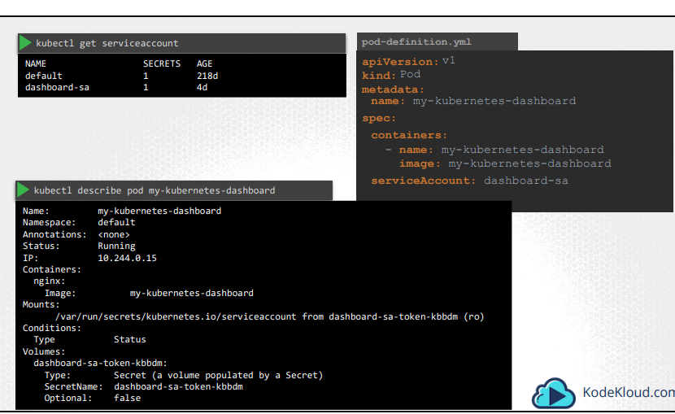
* 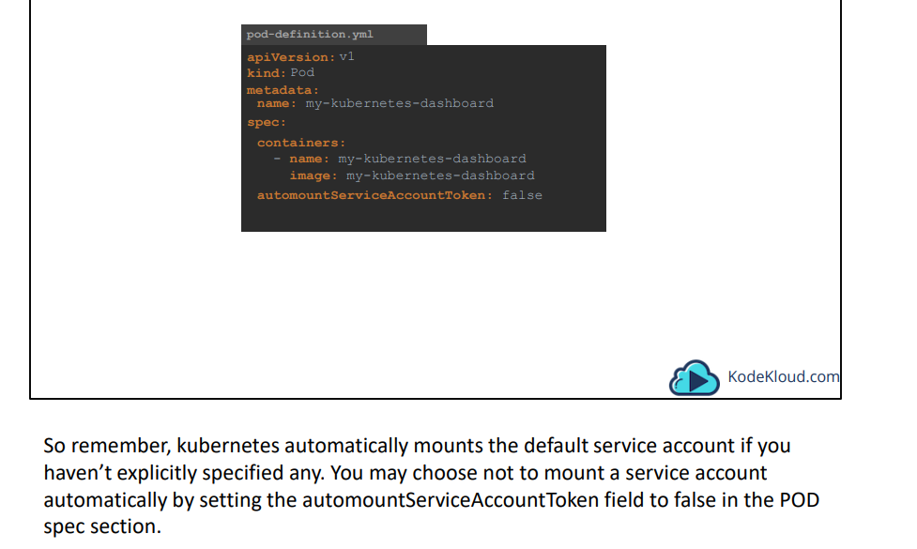

Taints & Tolerations:

* We will understand by taking a bug example
* To prevent the bug
* from landing on the person, we spray the person with a repellent spray or a taint, as we will call it in this lecture The bug is intolerant to the smell. On approaching the person, the taint applied on the person throws the bug off
* However, there could be other bugs that are tolerant to this smell. So taint really don’t affect them
* 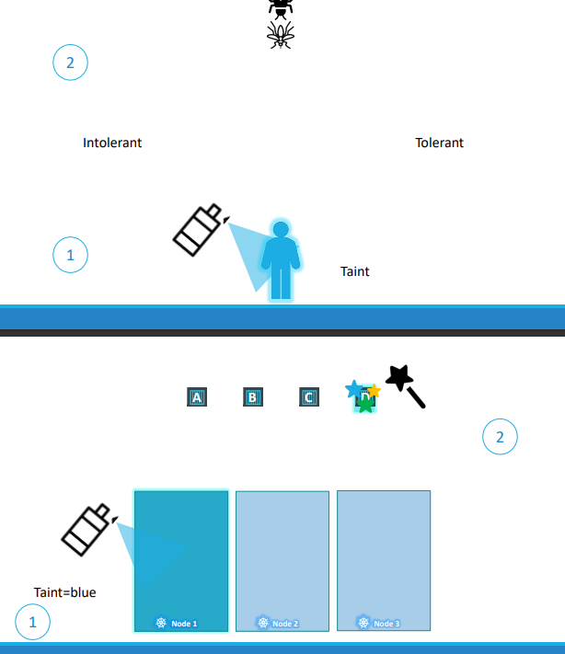
* There are two things that decide if a bug can land on a person. Taint on person and second,

the bug's toleration level.

* Getting back to k8s taint is a node and toleration is a pod
* Taints and tolerations are used to set restrictions on what pods can be scheduled on a node
* Let us start with a simple cluster with three worker nodes and there are pods to be deployed on these nodes
* When pods are created Kubernetes scheduler tries to place these pods on these nodes
* Currently as there is no restrictions all pods will be equally distributed to all nodes
* Let us assume we have dedicated resources on node 1 for a particular use case or application, so we want only those pods to related to that application to be deployed to node
* First, we prevent all pods from being placed on the node by placing a taint on the node,
* By default none of the pods can tolerate any taint. In this case none of the pods can be placed in node 1. No unwanted pods will be placed in node 1
* Next is to enable certain pods to be placed on this node. We want only pod D to be deployed on to node 1 so We add a toleration to pod D.
* Remember, taints are set on nodes and tolerations are set on pods.
* Taints and Tolerations doesn’t garauntee that pod D will always be placed on node one.
* Since there are no taints or restrictions applied on the other two nodes, pod D may very well be placed on any of the other two nodes
* taints and tolerations does not tell the pod to go to a particular node. It only accept pods with certain tolerations
* If your requirement is to restrict a pod to certain nodes it is achieved through another concept called as node affinity
* When the Kubernetes cluster is first set up a taint is set on the master node automatically
* 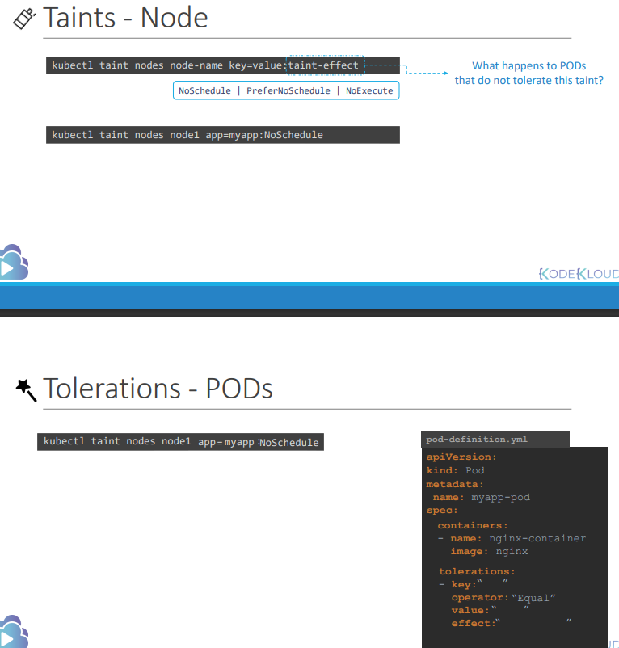
* 

Node Selectors:

* You have a three node cluster of which two are smaller nodes with lower hardware resources and one of them is a larger node configured with higher resources
* I want to dedicted higher node only to certain pod which requires higher processing resources
* 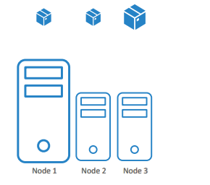
* By default any pod can go to any node
* To Solve this we can limit this pod to run on the larger node,we add a new property called node selector to the spec section and specify the size as large
* How does Kubernetes know which is the large node?
* The key value pair of size and large are, in fact, labels assigned to the nodes
* The scheduler uses these labels to match and identify the right node to place the pods on.
* Node selectors served our purpose, but it has limitations.
* We used a single label and selectors to achieve our goal here.
* What if our requirement is much more complex?
* For example, we would like to say something like "Place the pod on a large or medium node" or "Place the pod on any nodes that are not small."
* 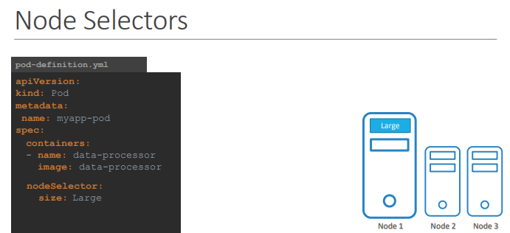
* 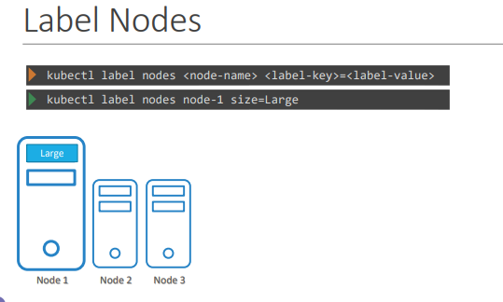
* 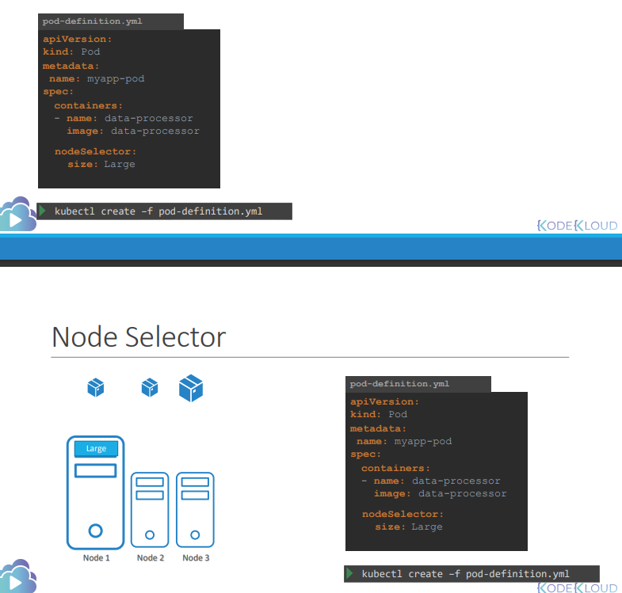

Node Affinity:

* The primary purpose of node affinity feature is to ensure that pods are hosted on particular nodes.
* In this case, to ensure the large data processing pod ends up on node one.
* In the previous lecture we did this easily using node selectors.
* We discussed that you cannot provide advanced expressions like or, or not with node selectors.
* The node affinity feature provides us with advanced capabilities to limit pod placement on specific nodes
* 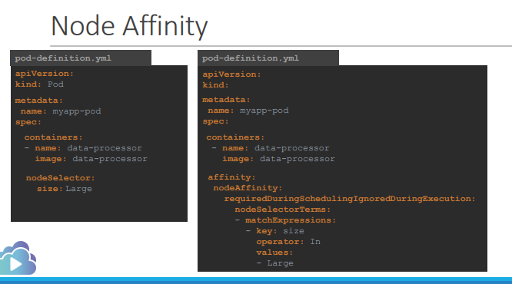
* Under spec you have affinity and then node affinity under that.
* Then you have a property that looks like a sentence called 'required during scheduling, ignored during execution'
* Then you have the node selector terms that is an array and that is where you will specify
* the key and value pairs.
* The key value pairs are in the form key, operator and value where the operator is in
* The in operator ensures that the pod will be placed on a node whose label size has any value in the list of values specified here
* In this case, it is just one called large.
* If you think your pod could be placed on a large or a medium node, you could simply add the value to the list of values like this.
* We can use NotIn as well
* We don't really have to even check the value of the label as long as we're sure we don't set
* a label size to the smaller nodes. Using the exists operator will give us the same result.
* The exists operator will simply check if the label size exists on the nodes and you don't need the value section for that
* as it does not compare the values.
* There are number of other operators we can check documentation
* What if node affinity could not match a node with a given expression?
* In this case, what if there are known nodes with the label called size? or what if someone changes the label
* on the node at a future point in time? Will the pod continue to stay on the node?
* All of this is answered by the long sentence like 'property under node affinity'
* 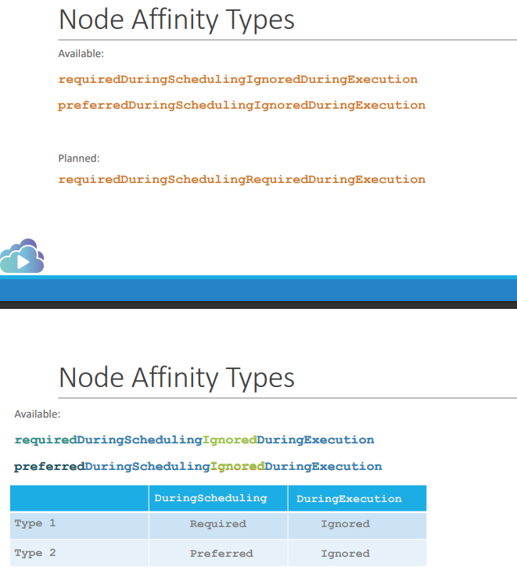
* We will start by looking at the two available affinity types.
* There are two states in the life cycle of a pod when considering node affinity: during scheduling and during execution.
* During scheduling is the state where a pod does not exist and is created for the first time. We have no doubt that when
* a pod is first created, the affinity rules specified are considered to place the pods on the right nodes
* What if the nodes with matching labels are not available?
* If you select the required type, which is the first one the scheduler will mandate that the pod be
* placed on a node with the given affinity rules If it cannot find one, the pod will not be scheduled
* This type will be used in cases where the placement of the pod is crucial If a matching node does not exist, the pod will not be scheduled
* Let's say the pod placement is less important than running the workload itself
* In that case, you could set it to preferred and in cases where a matching node is not found the scheduler will simply ignore node affinity rules and place the pod on any available node.
* This is a way of telling the scheduler, "Hey, try your best to place the pod on matching node but if you really cannot find one, just place it anywhere."
* The second part of the property or the other state is during execution. During execution is the state
* where a pod has been running and a change is made in the environment that affects node affinity such as a change in the label of a node. For example, say an administrator removed the label Now, what will happen to the pods
* that are running on the node? As you can see the two types of node affinity available today has this value set to ignored,
* which means pods will continue to run and any changes in node affinity will not impact them once they are scheduled.
* The new types expected in the future only have a difference in the during execution phase.
* A new option called required during execution is introduced, which will evict any pods that are running
* on nodes that do not meet affinity rules. In the earlier example, a pod running on the large node will be evicted or terminated if the label large is removed from the node.
* 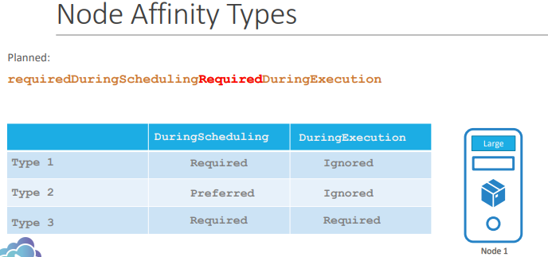

Taints & Tolerations vs Node Affinity:

* We have three nodes, and three pods each in three colors
* The ultimate aim is to place the blue pod in the blue node, the red pod in the red node, and likewise for green
* We are sharing the same Kubernetes cluster with other teams There are other pods in the cluster as well as other nodes
* We do not want any other pod to be placed on our node Neither do we want our pods to be placed on their nodes
* Let us try to solve this problem using taints and tolerations
* We apply a taint to the nodes, marking them with their colors We then set a toleration on the pods
* to tolerate the respective colors the nodes ensure they only accept the pods with the right toleration.
* The green pod ends up on the green node, and the blue pod ends up on blue node
* However, taints and tolerations does not guarantee that the pods will only prefer these nodes. The red node ends up on one
* of the other nodes that do not have a taint or toleration set. This is not desired. Let us try to solve the same problem
* with node affinity. we first label the nodes with their respective colors; We then set node selectors
* on the pods to tie the pods to the nodes. As such, the pods end up on the right nodes.
* However that does not guarantee that other pods are not placed on these nodes. In this case, there is a chance
* that one of the other pods may end up on our nodes. This is not something we desire. As such, a combination
* of taints and tolerations, and node affinity rules can be used together
* to completely dedicate nodes for specific pod. We first use taints and tolerations to prevent other pods from being
* and then we use node affinity to prevent our pods from being placed on their nodes.
* 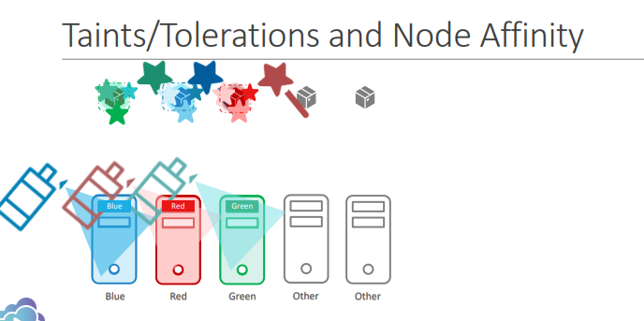
* To get Lables:
* 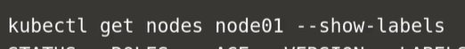
* Create replicas in imperative way
* 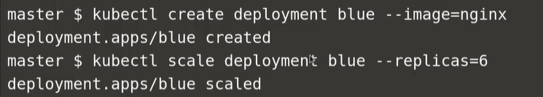

Multi Container Pods:

* At times you may need two services to work together. Such as a web server and a logging service. You need one agent per web server instance paired together
* You don’t want to merge and bloat the code of the two services, as each of them target different features, and you’d still like them to be developed and deployed separately
* 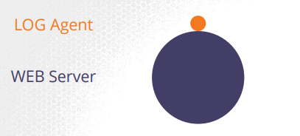
* Multicontainer pods share the same lifecycle – which means they are created together and destroyed together. They share the same network space, which means they can refer to each other as localhost
* And they have access to the same storage volumes. This way, you do not have to establish, volume sharing or services between the PODs to enable communication between them
* To create a multi-container pod, add the new container information to the pod definition file
* 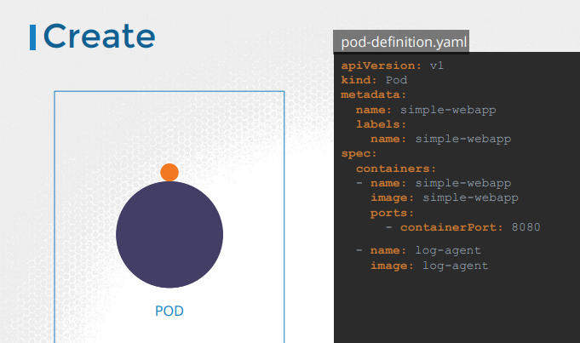
* Remember, the containers section under the spec section in a pod definition file is an array and the reason it is an array is to allow multiple containers in a single POD
* In this case we add a new container named log-agent to our existing pod. We will look at more realistic examples later
* There are 3 common patterns, when it comes to designing multi-container PODs. The first and what we just saw with the logging service example is known as a side car pattern
* 
* 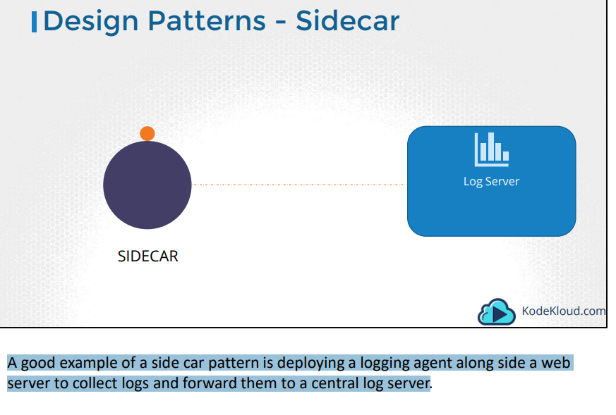
* 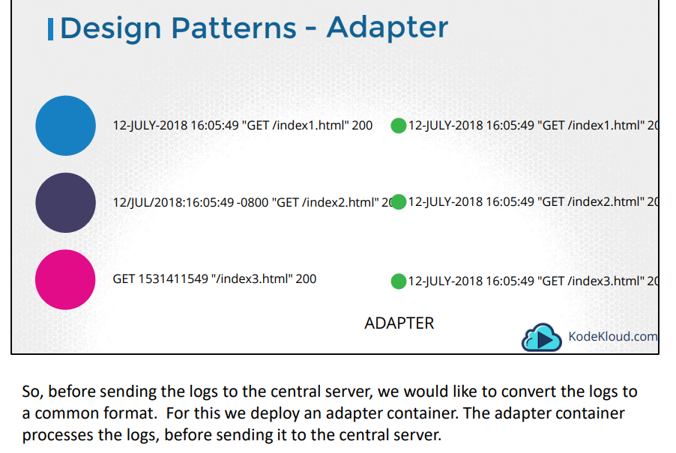
* 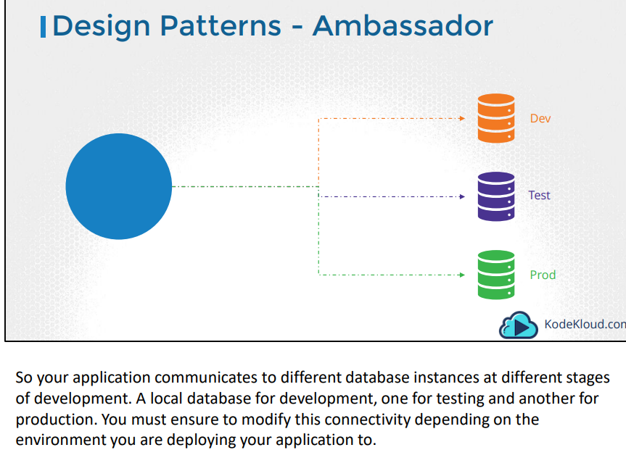
* 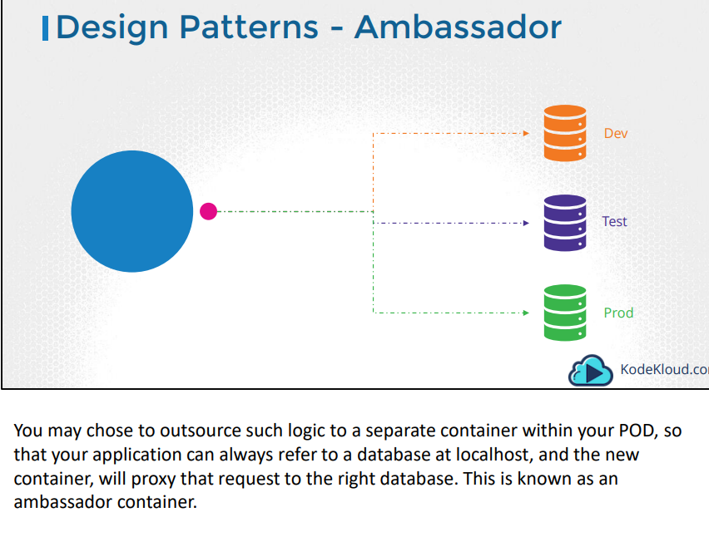
* Again, remember that these are different patterns in designing a multi-container pod. When it comes to implementing them using a pod-definition file, it is always the same. You simply have multiple containers within the pod definition file.
* To generate yaml file from a pod
* 

Init Containers

* In a multi-container pod, each container is expected to run a process that stays alive as long as the POD’s lifecycle.
* For example in the multi-container pod that we talked about earlier that has a web application and logging agent, both the containers are expected to stay alive at all times.
* The process running in the log agent container is expected to stay alive as long as the web application is running. If any of them fails, the POD restarts.
* But at times you may want to run a process that runs to completion in a container. For example a process that pulls a code or binary from a repository that will be used by the main web application
* That is a task that will be run only one time when the pod is first created
* Or a process that waits for an external service or database to be up before the actual application starts
* That’s where initContainers comes in
* An initContainer is configured in a pod like all other containers, except that it is specified inside a initContainers section, like this
* 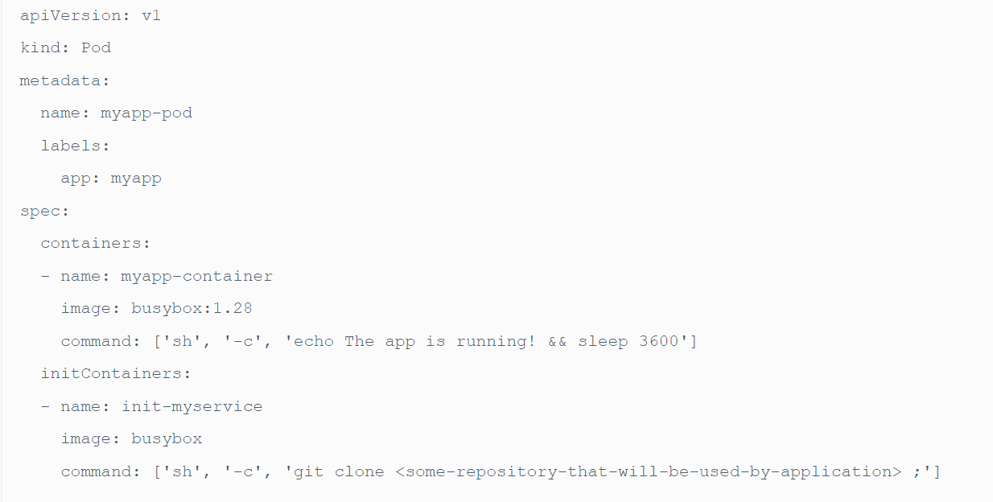
* When a POD is first created the initContainer is run, and the process in the initContainer must run to a completion before the real container hosting the application starts.

Readiness Probes:

Pods Status:

* The POD status tells us where the POD is in its lifecycle. When a POD is first created, it is in a **Pending** state. This is when the Scheduler tries to figure out where to place the POD
* If the scheduler cannot find a node to place the POD, it remains in a Pending state
* Once the POD is scheduled, it goes into a **ContainerCreating** status where the images required for the application are pulled and the container starts.
* Once all the containers are pulled POD starts, it goes into a **running** state, were it continues to be until the program completes successfully or is terminated

Pods Conditions:

* 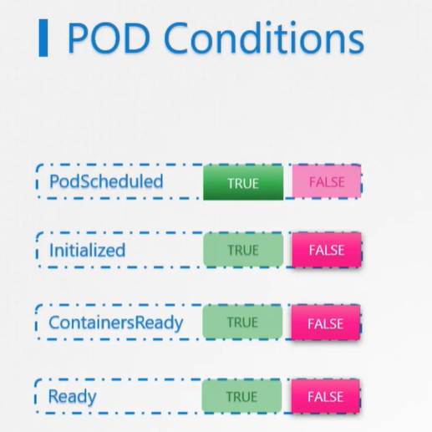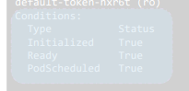
* Conditions compliment POD status. It is an array of true or false values that tell us the state of a POD
* When a POD is scheduled on a Node, the PodScheduled condition is set to True. When the POD is initialized, it’s value is set to True
* We know that a POD has multiple containers. When all the containers in the POD are ready, the Containers Ready condition is set to True and finally the POD itself is considered to be Ready
* 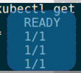
* The ready conditions indicate that the application inside the POD is running and is ready to accept user traffic
* What does that really mean? The containers could be running different kinds of applications in them
* It could be a simple script that performs a job. It could be a database service. Or a large web server, serving front end users.
* The script may take a few milliseconds to get ready. The database service may take a few seconds to power up. Some web servers could take several minutes to warm up
* If you try to run an instance of a Jenkins server, you will notice that it takes about 10-15 seconds for the server to initialize before a user can access the web UI
* Even after the Web UI is initialized, it takes a few seconds for the server to warm up and be ready to serve users
* During this wait period if you look at the state of the POD, it continues to indicate that the POD is ready, which is not very true
* Let us look at a simple scenario were you create a POD and expose it to external users using a service. The service will route traffic to the POD immediately. The service relies on the pod’s READY condition to route traffic
* By default, Kubernetes assumes that as soon as the container is created, it is ready to serve user traffic. So it sets the value of the “Ready Condition” for each container to True
* But if the application within the container took longer to get ready, the service is unaware of it and sends traffic through as the container is already in a ready state, causing users to hit a POD that isn’t yet running a live application
* 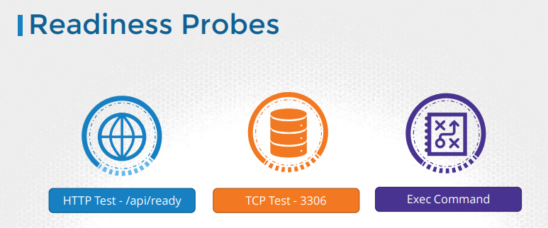
* There are different ways that you can define if an application inside a container is actually ready. You can setup different kinds of tests or Probes, which is the appropriate term
* In case of a web application it could be when the API server is up and running. So you could run a HTTP test to see if the API server responds. In case of database, you may test to see if a particular TCP socket is listening. Or You may simply execute a command within the container to run a custom script that would exit successfully if the application is ready
* 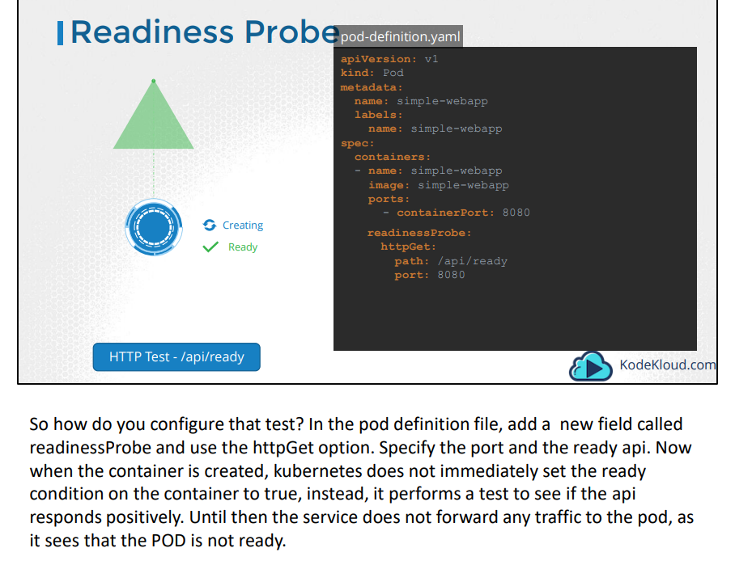
* 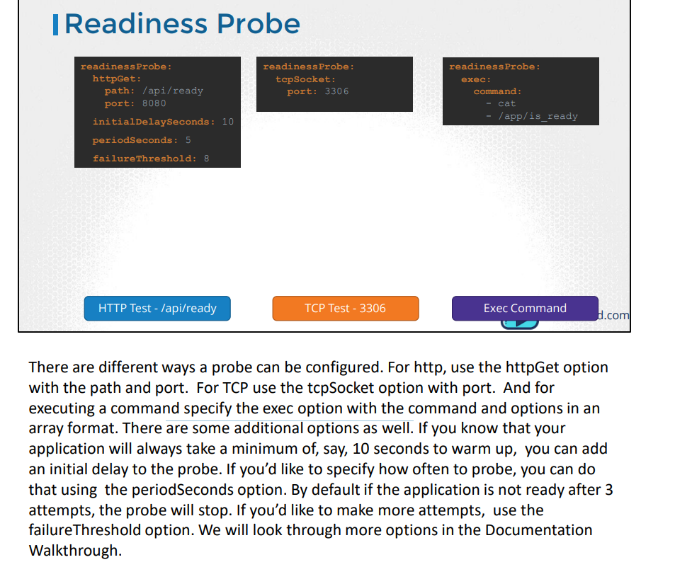

Liveness Probe:

* You run an image of NGINX using docker and it starts to serve users. For some reason the web server crashes and the nginx process exits. The container exits as well
* And you can see the status of the container when you run the docker ps command. Since docker is not an orchestration engine, the container continues to stay dead and deny services to users, until you manually create a new container.
* 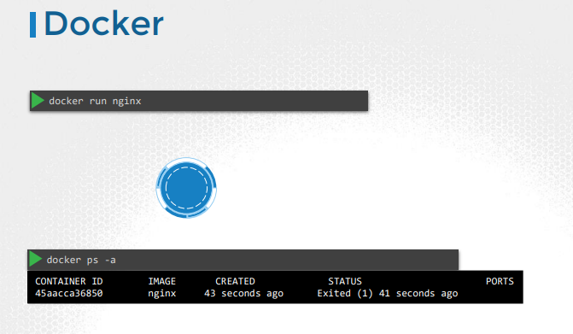
* 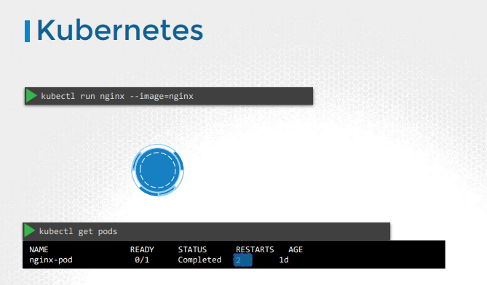
* Enter Kubernetes Orchestration. You run the same web application with kubernetes. Every time the application crashes, kubernetes makes an attempt to restart the container to restore service to users. You can see the count of restarts increase in the output of kubectl get pods command. Now this works just fine
* However, what if the application is not really working but the container continues to stay alive? Say for example, due to a bug in the code, the application is stuck in an infinite loop.
* For ex: what if application is up and all CRUD operations are not working
* As far as kubernetes is concerned, the container is up, so the application is assumed to be up.
* But the users hitting the container are not served. In that case, the container needs to be restarted, or destroyed and a new container is to be brought up.
* That is where the liveness probe can help us
* A liveness probe can be configured on the container to periodically test whether the application within the container is actually healthy
* If the test fails, the container is considered unhealthy and is destroyed and recreated
* 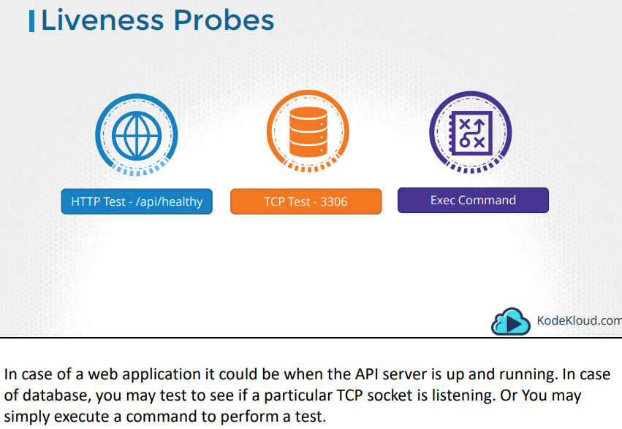
* 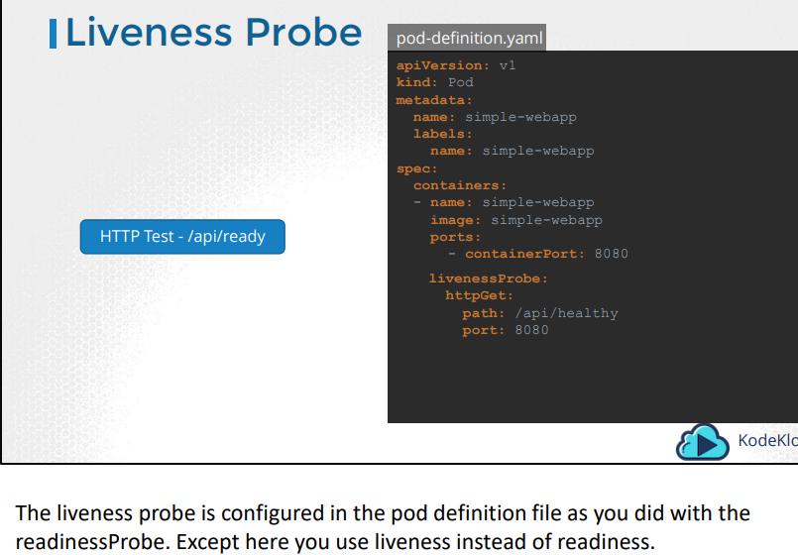
* 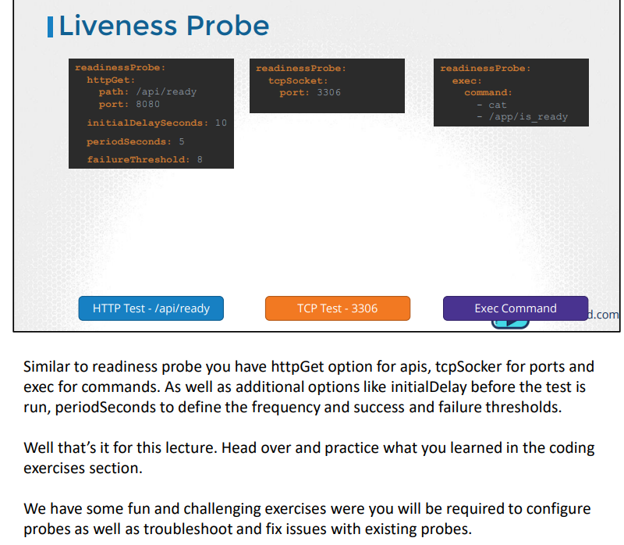

Logs in K8S:

* In docker to get the logs we use below command
* 
* Now back to Kubernetes. We create a pod with the same docker image using the pod definition file.
* Once it’s the pod is running, we can view the logs using the kubectl logs command with the pod name. Use the –f option to stream the logs live
* 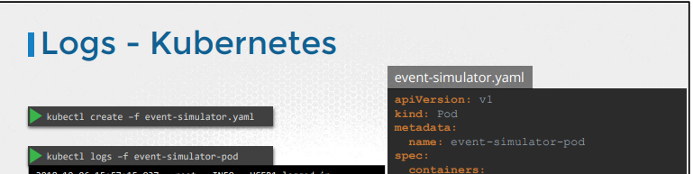
* In case we can multi-container pods we need to specify container name otherwise it will throw an error
* Kubectl logs -f event-simulator-pod -c event-simulator
* 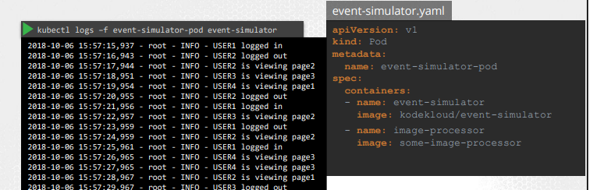

Monitoring K8S:

* So how do you monitor resource consumption on Kubernetes? Or more importantly what would you like to monitor? I’d like to know Node level metrics such as the number of nodes in the cluster
* how many of them are healthy as well as performance metrics such as CPU. Memory, network and disk utilization
* As well as POD level metrics such as the number of PODs, and performance metrics of each POD such the CPU and Memory consumption
* As of this recording , Kubernetes does not come with a full featured built-in monitoring solution. However, there are a number of open-source solutions available today, such as the Metrics-Server, Prometheus, the Elastic Stack, and proprietary solutions like Datadog and Dynatrace.
* 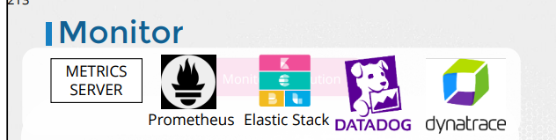
* So in the scope of this course, we will discuss about the Metrics Server only. The other solutions will be discussed in the Kubernetes for administrators course.
* You can have one metrics server per kubernetes cluster
* The metrics server retrieves metrics from each of the kubernetes nodes and pods, aggregates them and stores them in memory. Note that the metrics server is only an in-memory monitoring solution and does not store the metrics on the disk, and as a result you cannot see historical performance data.
* For that you must rely on one of the advanced monitoring solutions we talked about earlier in this lecture
* 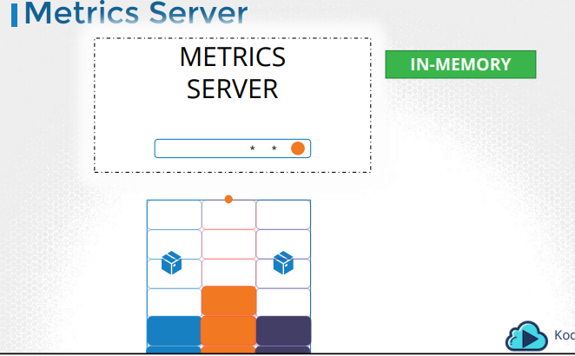
* Kubernetes runs an agent on each node known as the kubelet, which is responsible for receiving instructions from the kubernetes API master server and running PODs on the nodes
* The kubelet also contains a subcomponent known as cAdvisor or Container Advisor. cAdvisor is responsible for retrieving performance metrics from pods, and exposing them through the kubelet API to make the metrics available for the Metrics Server.
* 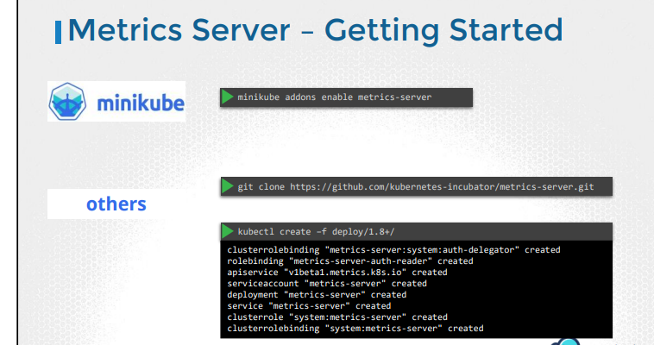
* 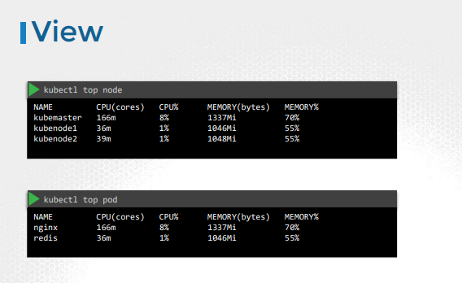
* Once deployed, give the metrics-server some time to collect and process data.
* Once processed, cluster performance can be viewed by running the command kubectl top node. This provides the CPU and Memory consumption of each of the nodes. As you can see 8% of the CPU on my master node is consumed, which is about 166 milli core
* 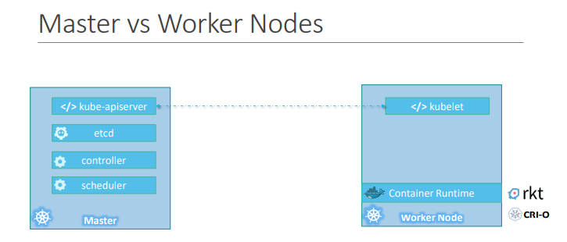
* The worker node (or minion) as it is also known, is where the containers are hosted. For example Docker containers, and to run docker containers on a system, we need a container runtime installed. And that’s were the container runtime falls
* The master server has the kube-apiserver and that is what makes it a master
* Similarly the worker nodes have the kubelet agent that is responsible for interacting with the master to provide health information of the worker node and carry out actions requested by the master on the worker nodes
* All the information gathered are stored in a key-value store on the Master. The key value store is based on the popular etcd framework as we just discussed.
* The master also has the controller manager and the scheduler

Labels, Selectors & Annotations

* Labels and Selectors are a standard method to group things together
* 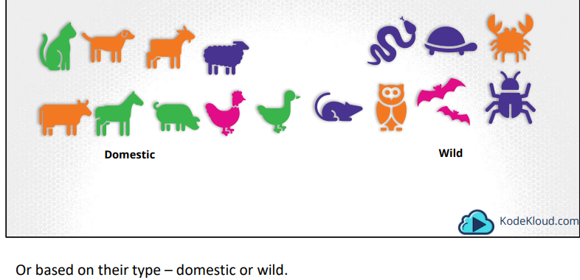
* So how are labels and selectors used in Kubernetes?
* We have created a lot of different types of Objects in Kuberentes. Pods, Services, ReplicaSets and Deployments.
* For Kubernetes, all of these are different objects. Over time you may end up having 100s and 1000s of these objects in your cluster. Then you will need a way to filter and view different objects by different categories
* 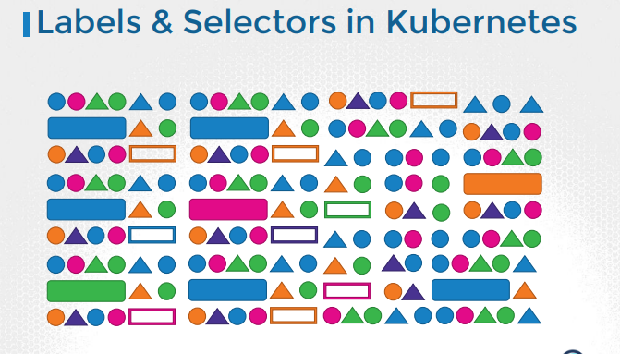
* 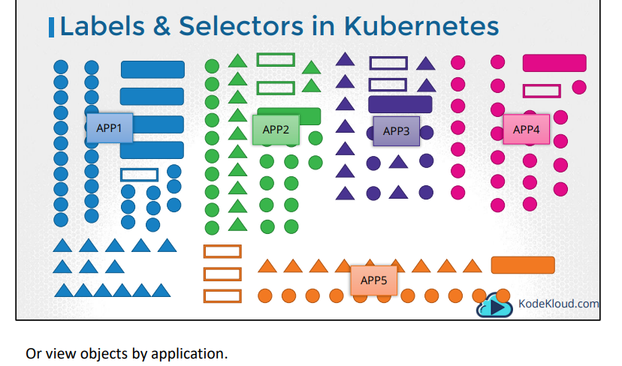
* So how exactly do you specify labels in kubernetes. In a pod-definition file, under metadata, create a section called labels. Under that add the labels in a key value format like this. You can add as many labels as you like.
* 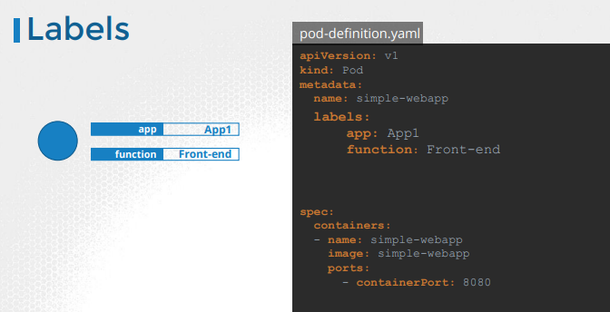
* 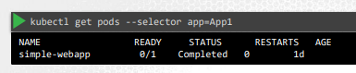
* Once the pod is created, to select the pod with the labels use the kubectl get pods command along with the selector option, and specify the condition like app=App1
* 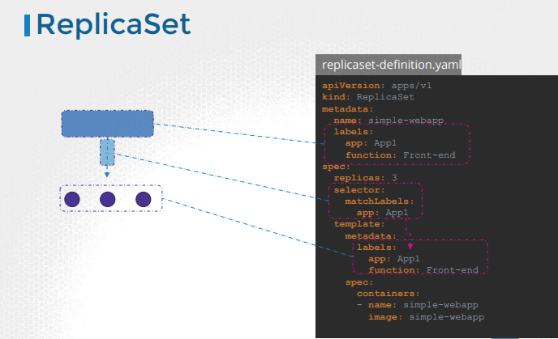
* Kubernetes objects use labels and selectors internally to connect different objects together
* For example to create a replicaset consisting of 3 different pods, we first label the pod definition and use selector in a replicaset to group the pods
* In the replica-set definition file, you will see labels defined in two places. Note that this is an area where beginners tend to make a mistake
* The labels defined under the template section are the labels configured on the pods
* The labels you see at the top are the labels of the replica set, We are not really concerned about that for now, because we are trying to get the replicaset to discover the pods
* In order to connect the replica set to the pods, we configure the selector field under the replicaset specification to match the labels defined on the pod
* 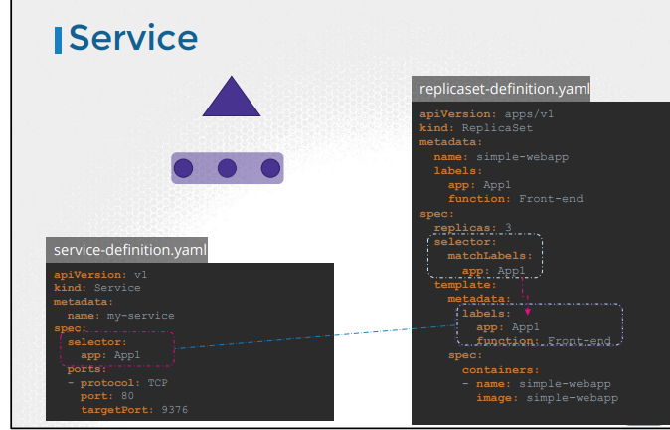
* It works the same for other objects like a service. When a service is created, it uses the selector defined in the service definition file to match the labels set on the pods in the replicaset-definition file
* To select based on multiple conditions:
* 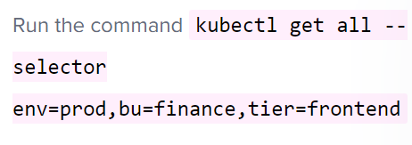

Annotations:

* Finally let’s look at annotations. While labels and selectors are used to group and select objects
* annotations are used to record other details for informatory purpose. For example tool details like name, version build information etc or contact details
* 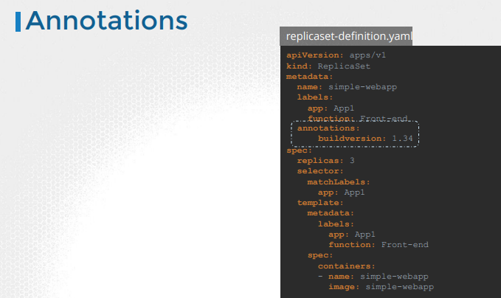

Jobs:

* There are different types of workloads that a container can serve. A few that we have seen through this course are Web, application and database. We have deployed simple web servers that serve users. These workloads are meant to continue to run for a long period of time, until manually taken down. There are other kinds of workloads such as batch processing, analytics or reporting that are meant to carry out a specific task and then finish
* For example, performing a computation, processing an image, performing some kind of analytics on a large data set, generating a report and sending an email etc. These are workloads that are meant to live for a short period of time, perform a set of tasks and then finish.
* 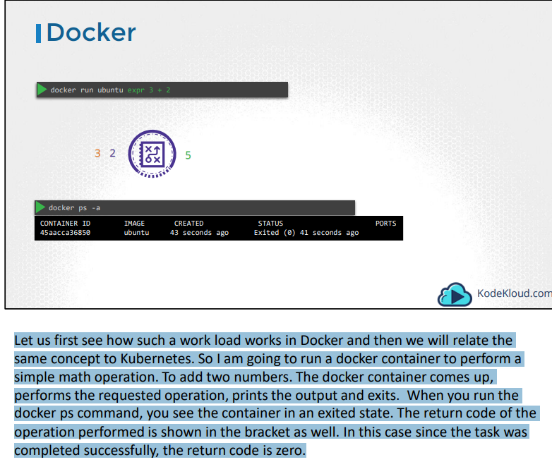
* 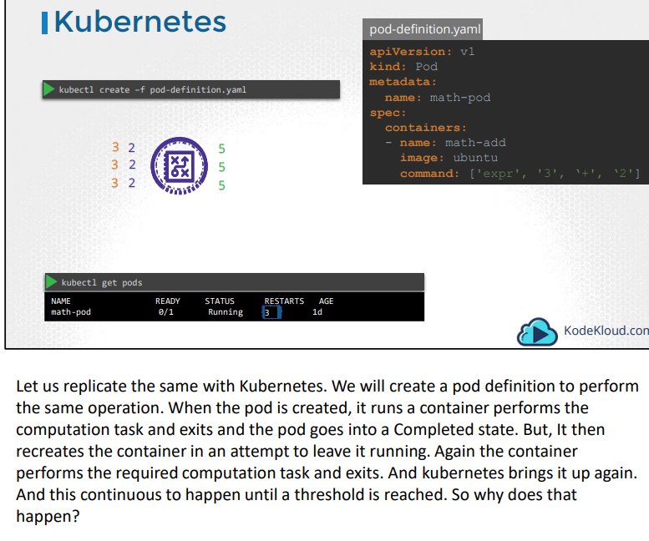
* 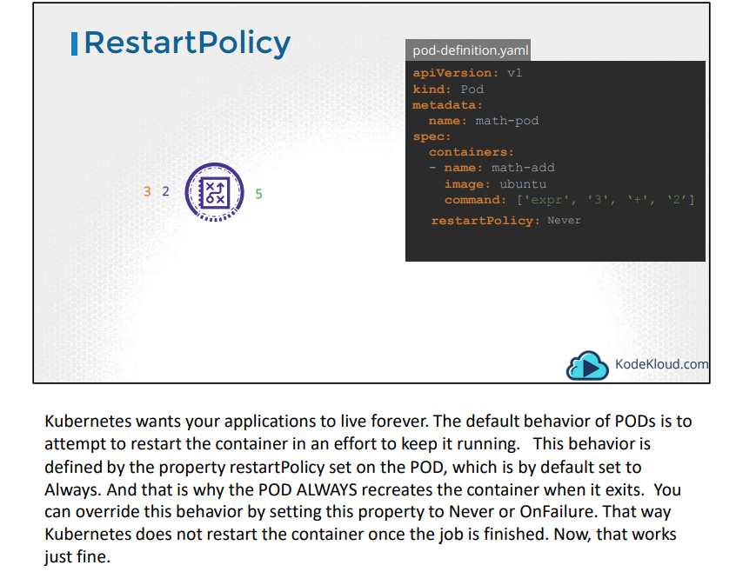
* 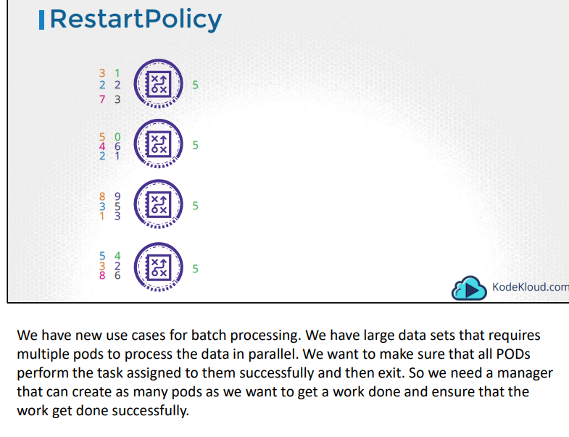
* That is what JOBs in Kubernetes do. But we have learned about ReplicaSets helping us creating multiple PODs. While a ReplicaSet is used to make sure a specified number of PODs are running at all times, a Job is used to run a set of PODs to perform a given task to completion. Let us now see how we can create a job
* 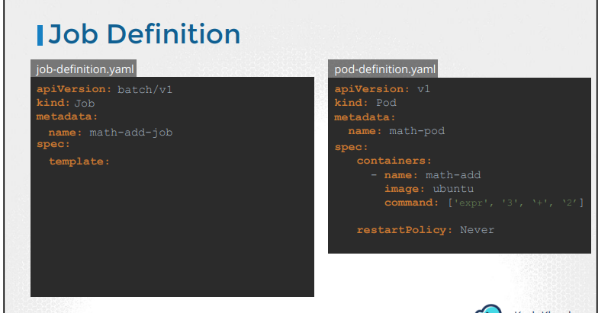
* 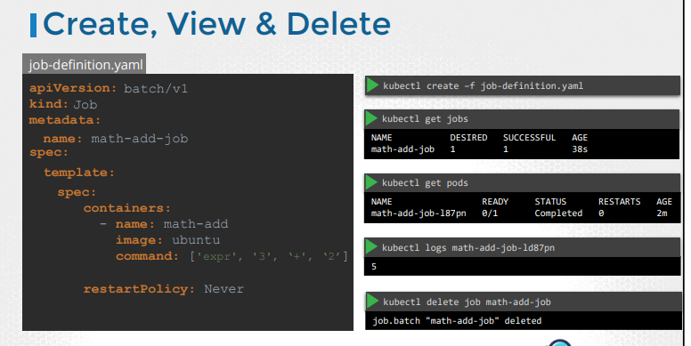
* We create a JOB using a definition file. So we will start with a pod definition file. To create a job using it, we start with the blank template that has apiVersion, kind, metadata and spec. The apiVersion is batch/v1 as of today. But remember to verify this against the version of Kubernetes release that you are running on. The kind is Job of course. We will name it math-add-job. Then under the spec section, just like in replicasets or deployments, we have template. And under template we move all of the content from pod definition specification.
* Once done create the job using the kubectl create command.
* Once created, use the kubectl get jobs command to see the newly created job. We now see that the job was created and was completed successfully. To see the pods created by the kubectl get pods command you run kubectl get pods command. **We see that it is in a completed state with 0 Restarts, indicating that kubernetes did not try to restart the pod**.
* Perfect! But, what about the output of the job? In our case, we just had the addition performed on the command line inside the container. So the output should be in the pods standard output. The standard output of a container can be seen using the logs command. So we run the kubectl logs command with the name of the pod to see the output. Finally, to delete the job, runthe kubecl delete job command. Deleting the job will also result in deleting the pods that were created by the job.
* 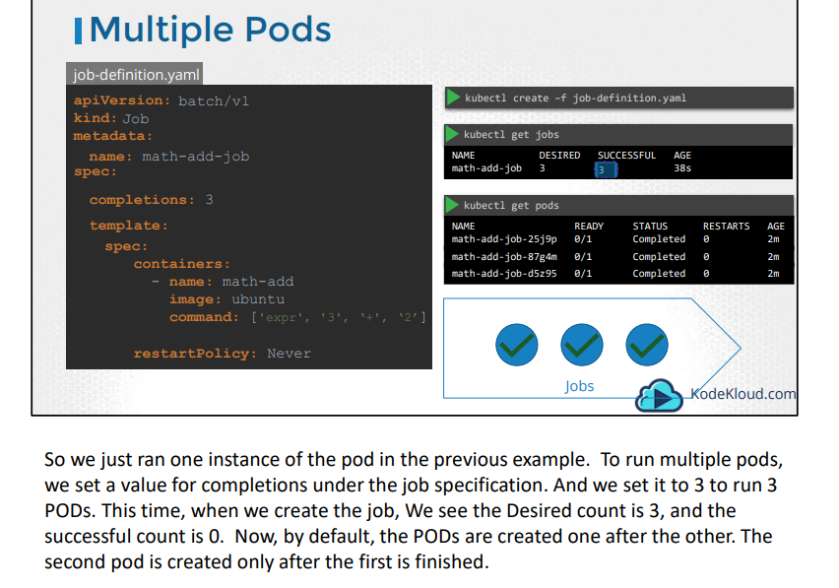
* 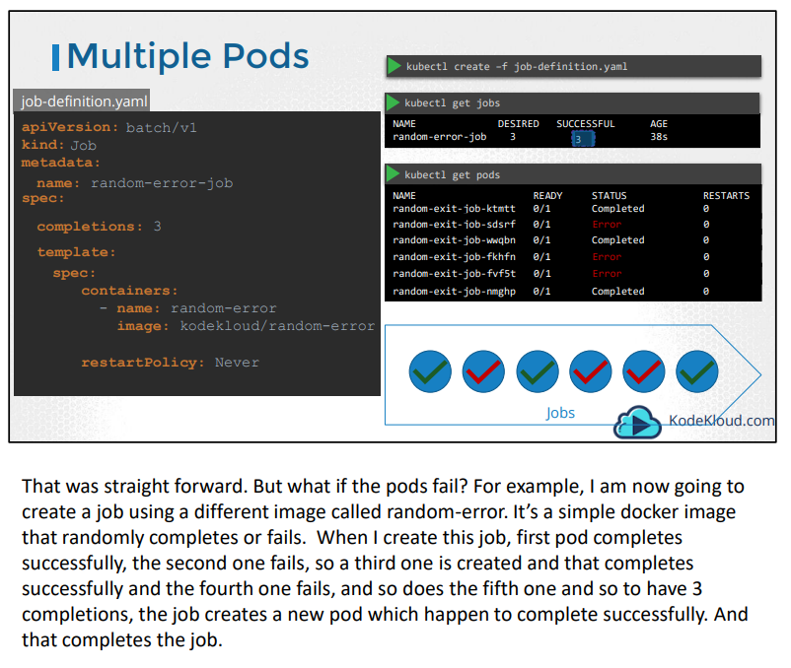
* 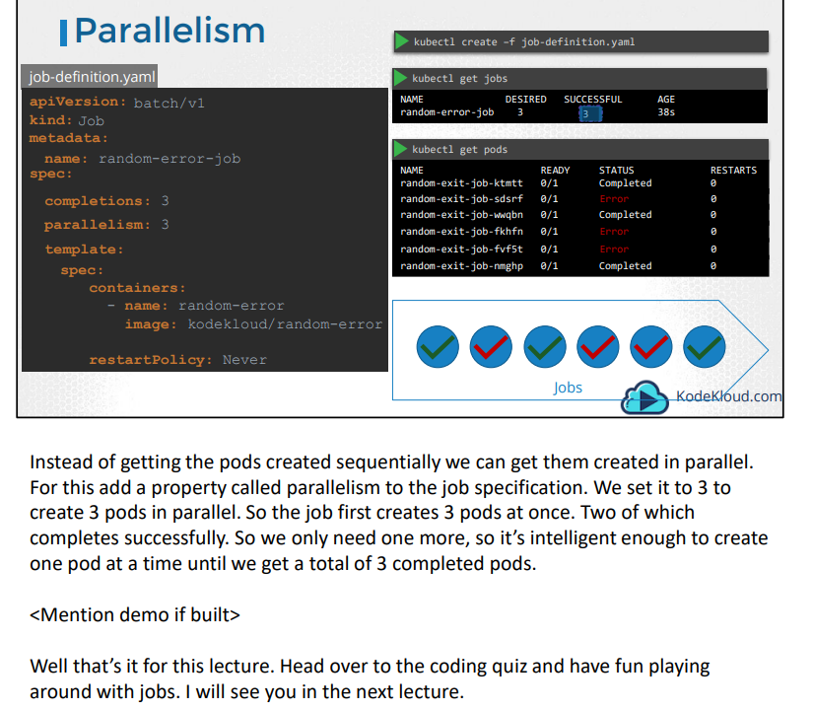

CRONJOB:

* A cronjob is a job that can be scheduled. Just like cron tab in Linux, if you are familiar with it. Say for example you have a job that generates a report and sends an email. You can create the job using the kubectl create command, but it runs instantly. Instead you could create a cronjob to schedule and run it periodically
* 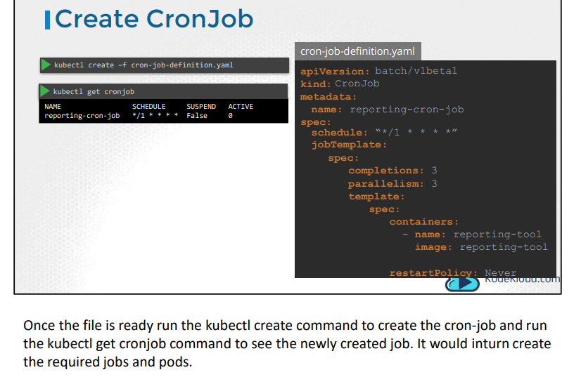
* Backofflimit is to set retries for the job
* 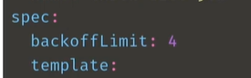
* Make run same job for 3 successful times we can update like below
* 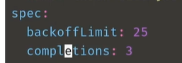

Networking:

* So you have a web server serving Front-End to users, an app server serving back-end APIs and the The user sense in request to the web server at Port 80. The web server then sends a request to the API
* The API server then fetches data from the database server at port 3306 and then sends the data back
* So there are two types of traffic here Ingress and Egress. For example for a web server the incoming traffic from the users is an Ingress traffic and the outgoing requests to the app server is Egress traffic and that is denoted by the straight arrow. When you define Ingress and Egress remember, you're only looking at the direction in which the traffic The response back to the user denoted by the dotted lines do not really matter.
* Similarly, in case off the back-end API server, it receives ingress traffic from the web server on port 5000 and has egress traffic to port 3306 to the database server and from the database servers perspective it receives ingress traffic on port 3306 from the API server.
* If we were to list the rules required to get this working we would have an Ingress rule that is required to accept HTTP traffic on port 80 on the web server. An Egress rule to allow traffic from the web server to port 5000 on the API server. An Ingress rule to accept traffic on port 5000 on the API server and an egress rule to allow traffic to port 3306 on the database server.
* And finally an Ingress rule on the database server to accept traffic on port 3306. So that's the basic of traffic flow and rules.
* 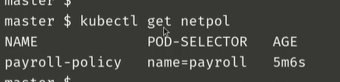
* 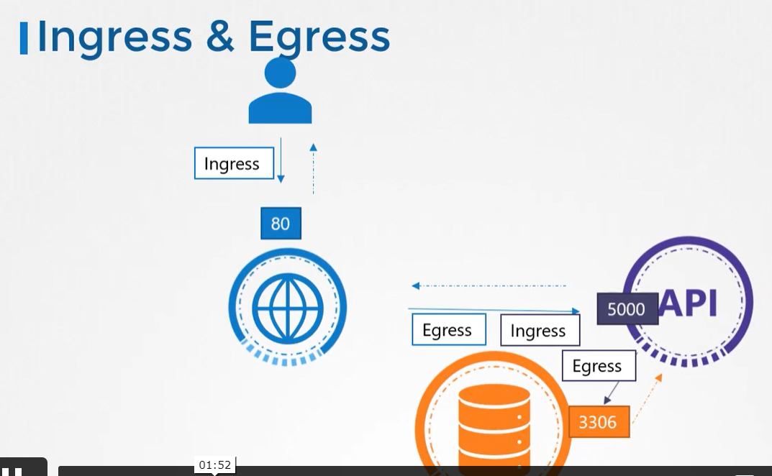
* 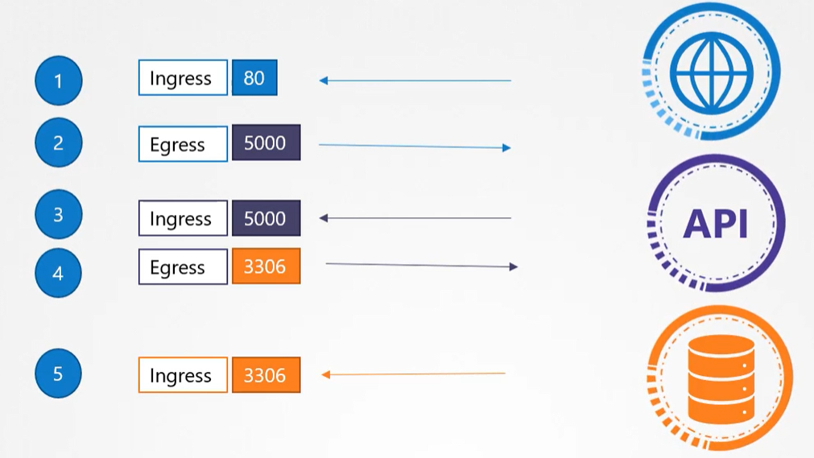
* Let us now look at Network Security in Kubernetes. So we have a cluster with a set of nodes hosting a set of pods and services. Each node has an IP address and so does each pod as well as service. One of the prerequisites for networking in Kubernetes is, whatever solution you implement, the pods should be able to communicate with each other without having to configure any additional settings like routes. For example, in this network solution, routes. For example, in this network solution, all pods are on a virtual private network that spans across the nodes in the Kubernetes cluster. And they can all by default reach each other using the IPs or POD names or services configured for that purpose
* Kubernetes is configured by default with an "All Allow" rule that allows traffic from any pod to any other pod or services within the cluster.
* 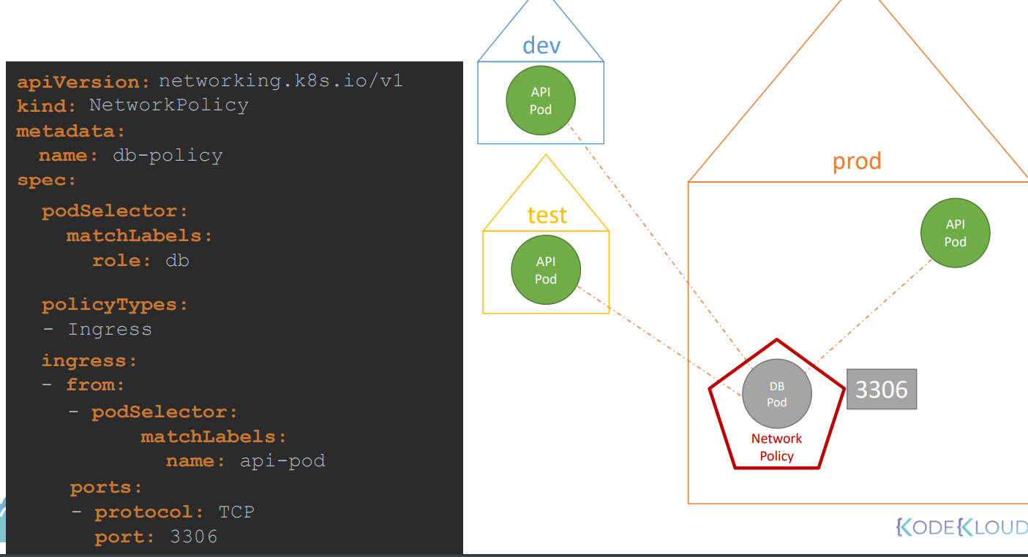
* Let us now bring back our earlier discussion and see how it fits into kubernetes. For each component in app, we deploy a pod one for the front end web server, for the API server and one for the database. We create services to enable communication between the pods as well as to the end user. Based on what we discussed in the previous slide.
* By default, all the three pods can communicate with each other within the kubernetes cluster. What if we do not want the front end web server to be able to communicate with the database server directly.
* Say for example your security teams and audits require you to prevent that from happening. That is where you would implement a network policy to allow traffic to the TV server only from the API server. A Network policy is another object in the kubernetes namespace. Just like PODs, Replica Sets or Services. You link a network policy to one or more pods. You can define rules within In this case I would say only allow ingress traffic from the API Pod on port 3306.
* The API pod makes database queries and the database pods returns the results. Do you need a separate rule for the results to go back to the API pod? No, because once you allow incoming traffic,
* the response or reply to that traffic is allowed back automatically. We don't need a separate rule for that. all we need is an ingress rule to allow traffic from the API pod to the database pod.
* Once this policy is created, it blocks all other traffic to the pod and only allows traffic that matches specified rule, Again, this is only applicable to the pod on which the network policy is applied.
* So how do you apply our link in network policy to a pod? We use the same technique that was used before to link Replica Sets or Services to pods, labels and selectors. We label the pod and use the same labels on the port selector field in the network policy. And then we build our rule. Under policy types specify whether the rule is to allow ingress or egress traffic or both. In our case we only want to allow ingress traffic to the db-pod. we only want to allow ingress traffic to the db-pod. Next, we specify the ingress rule that allows traffic from the API pod and you specify the API pod again using labels and selectors.
* And finally the port to allow traffic on which is 3306. Let us put all that together.
* 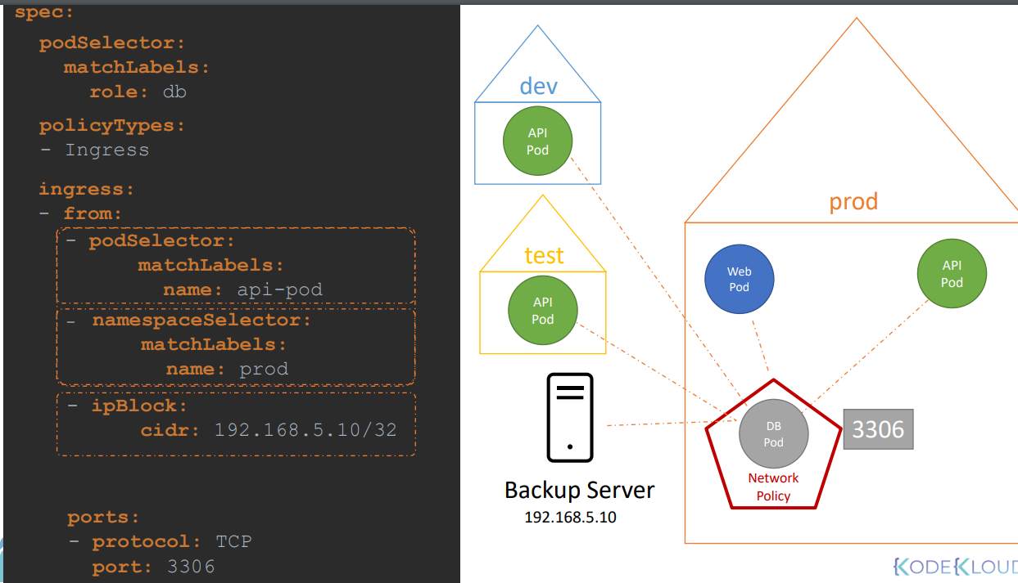
* Let's look at another use case. Say we have a backup server somewhere outside of the Kubernetes cluster and we want to allow this server to connect to the database pod. since it is not deployed in our Kubernetes cluster, the pod selector and namespace selector won't work because it's not a pod in the cluster. However, we know the IP address and that happens to be 192.168.5.10. We could configure a network policy to allow traffic originating from certain IP addresses.
* IP block allows you to specify a range of IP addresses from which you could allow traffic to hit the database pod.
* We'll now look at egress. instead of the backup server initiating a backup, say we have an agent on the DB port that pushes backup to the backup server. the traffic is originating from the database port to an external backup server. For this we need to have egress rule defined. We first add egress to the policy types. Then we add a new egress section to define the specifics of the policy. Instead of from, we now have to under egress
* 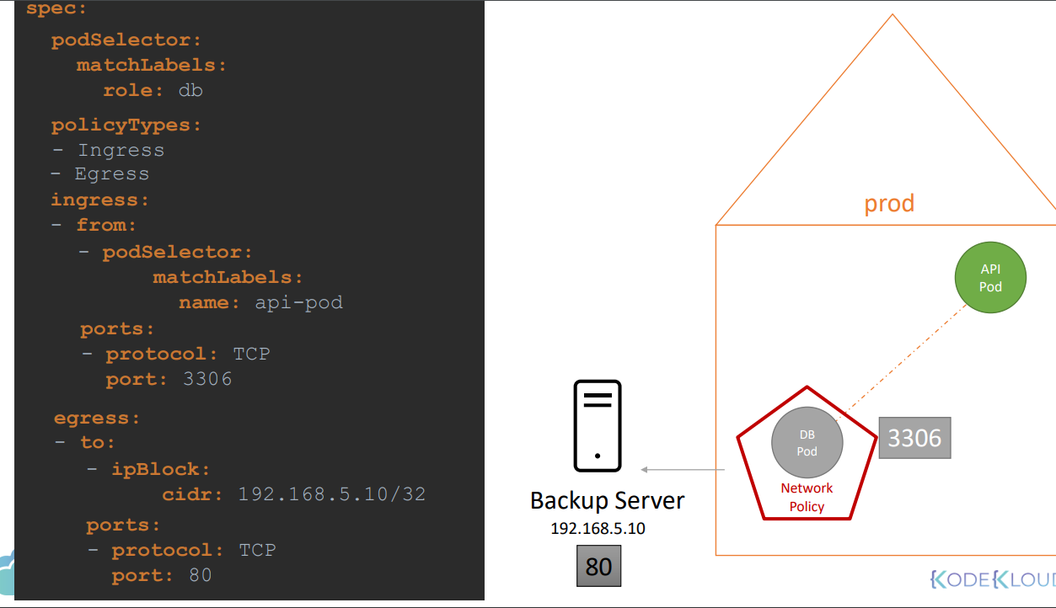
* 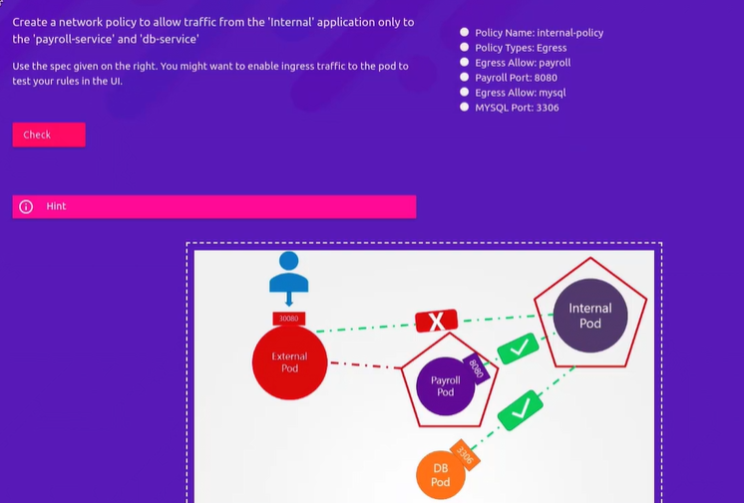
* 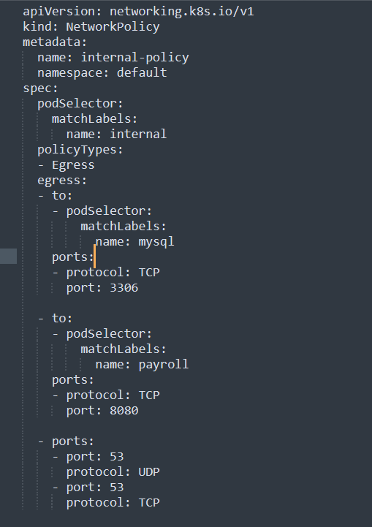

Storage in Docker:

* In Docker all container related data is stored under
* Left path is docker host path and right one is container path
* 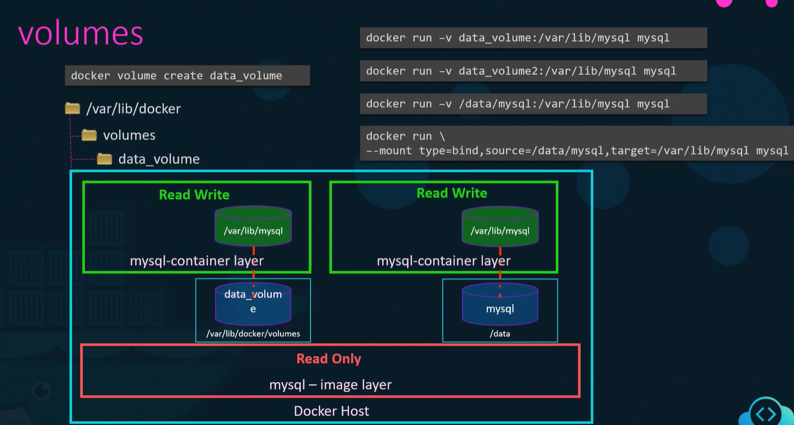

Volumes in K8S:

* Let us look at volumes in Docker first. Docker containers are meant to be transient in nature. Which means they are meant to last only for a short period of time. They are called upon when required to process data and destroyed once finished. The same is true for the data within the container. The data is destroyed along with the container
* To persist data processed by the containers, we attach a volume to the containers when they are created. The data processed by the container is now placed in this volume, thereby retaining it permanently. Even if the container is deleted, the data generated or processed by it remains
* So how does that work in the Kubernetes world. Just as in Docker, the PODs created in Kubernetes are transient in nature. When a POD is created to process data and then deleted, the data processed by it gets deleted as well. For this we attach a volume to the POD. The data generated by the POD is now stored in the volume, and even after the POD is delete, the data remains
* 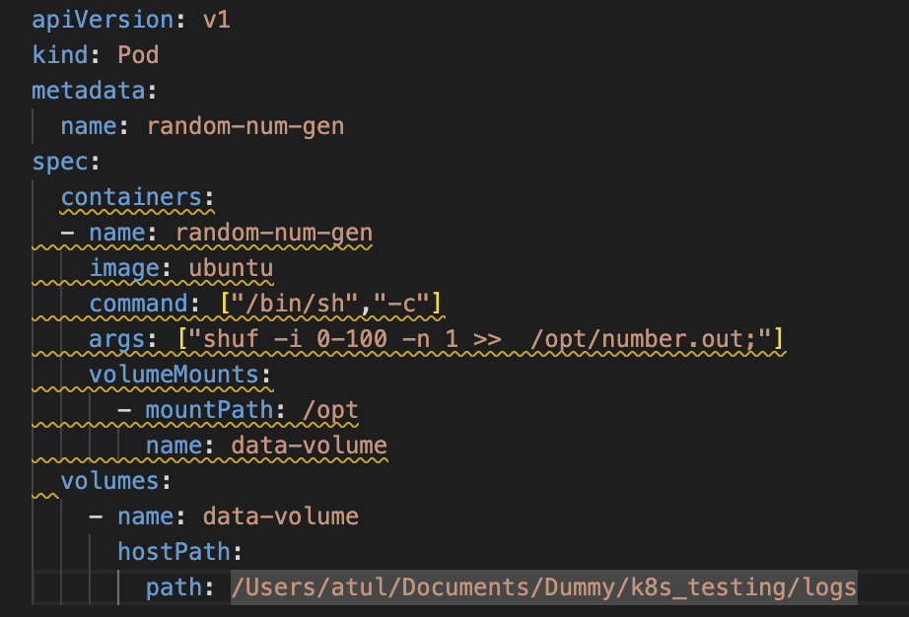 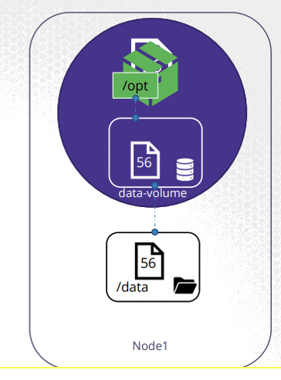
* We have a single node kubernetes cluster. We create a simple POD that generates a random between 1 and 100 and writes that to a file at /data/number.out and then gets deleted along with the random number
* To retain the number generated by the pod, we create a volume
* And a Volume needs a storage. When you create a volume you can chose to configure it’s storage in different ways. We will look at the various options in a bit, but for now we will simply configure it to use a directory on the host
* Once the volume is created, to access it from a container we mount the volume to a directory inside the container. We use the volumeMounts field in each container to mount the data-volume to the directory /opt within the container
* The random number will now be written to /opt mount inside the container, which happens to be on the data-volume which is in fact /data directory on the host. When the pod gets deleted, the file with the random number still lives on the host.
* Let’s take a step back and look at the Volume Storage option. We just used the hostPath option to configure a directory on the host as storage space for the volume. Now that works on a single node
* 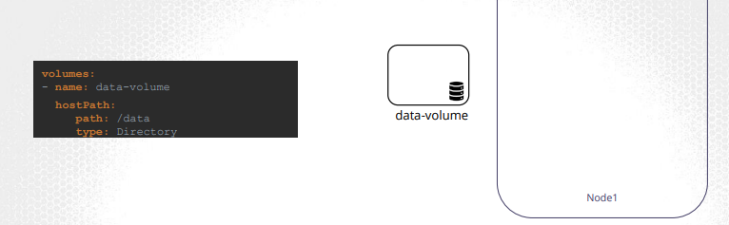
* 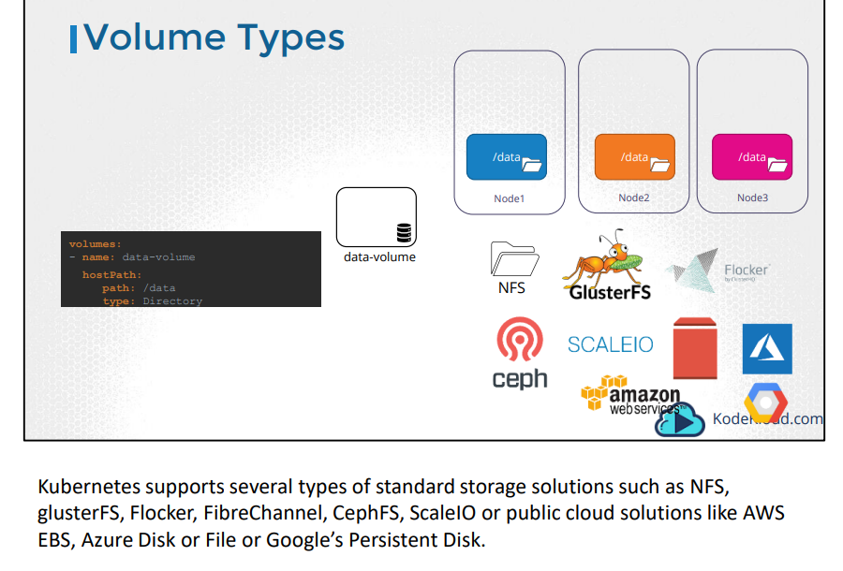
* 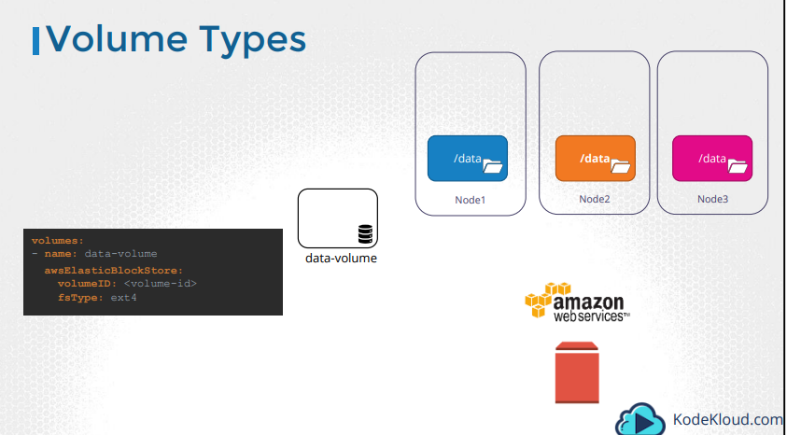
* For example, to configure an AWS Elastic Block Store volume as the storage or the volume, we replace hostPath field of the volume with awsElasticBlockStore field along with the volumeID and filesystem type. The Volume storage will now be on AWS EBS

Persistent Volume:

* 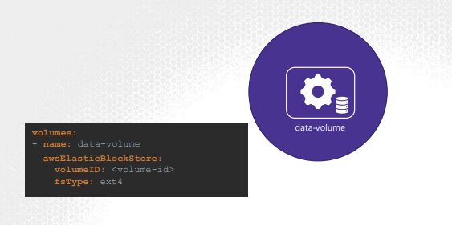
* When we created volumes in the previous section we configured volumes within the POD definition file. So every configuration information required to configure storage for the volume goes within the pod definition file
* Now, when you have a large environment with a lot of users deploying a lot of PODs, the users would have to configure storage every time for each POD. Whatever storage solution is used, the user who deploys the PODs would have to configure that on all POD definition files in his environment. Every time a change is to be made, the user would have to make them on all of his PODs
* Instead, you would like to manage storage more centrally.
* You would like it to be configured in a way that an administrator can create a large pool of storage, and then have users carve out pieces from it as required
* That is where Persistent Volumes can help us
* A Persistent Volume is a Cluster wide pool of storage volumes configured by an Administrator, to be used by users deploying applications on the cluster. The users can now select storage from this pool using Persistent Volume Claims
* 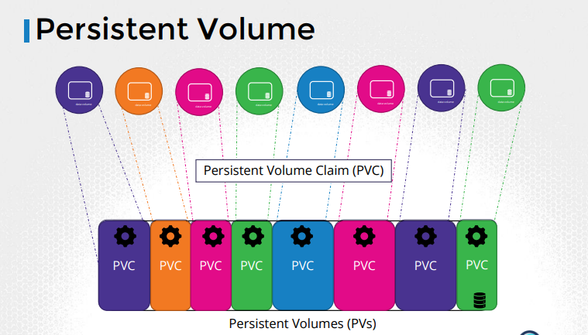
* 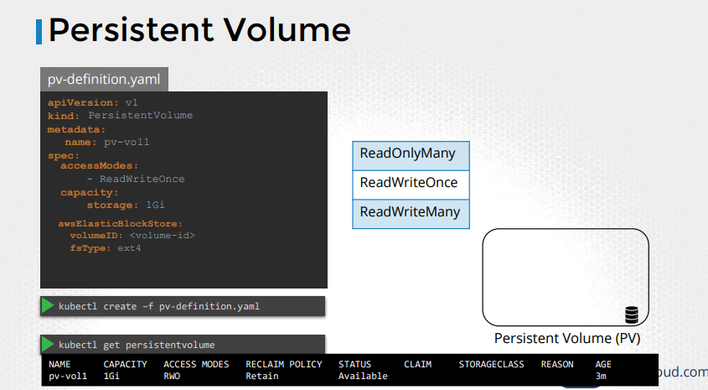
* Let us now create a Persistent Volume. We start with the base template and update the apiVersion, set the Kind to PersistentVolume, and name it pv-vol1. Under the spec section specify the accessModes
* Access Mode defines how the Volume should be mounted on the hosts. Weather in a ReadOnly mode, or ReadWrite mode. The supported values are ReadOnlyMany, ReadWriteOnce or ReadWriteMany mode
* Next, is the capacity. Specify the amount of storage to be reserved for this Persistent Volume. Which is set to 1GB here.

Persistent Volume Claims:

* In the previous lecture we created a Persistent Volume. Now we will create a Persistent Volume Claim to make the storage available to a node
* Persistent Volumes and Persistent Volume Claims are two separate objects in the Kubernetes namespace. An Administrator creates a set of Persistent Volumes and a user creates Persistent Volume Claims to use the storage
* Once the Persistent Volume Claims are created, Kubernetes binds the Persistent Volumes to Claims based on the request and properties set on the volume
* 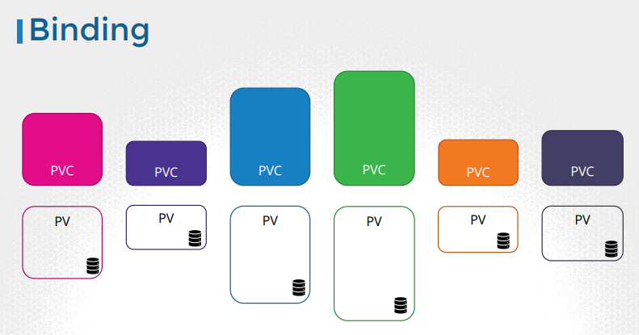
* Every Persistent Volume Claim is bound to a single Persistent volume. During the binding process, kubernetes tries to find a Persistent Volume that has sufficient Capacity as requested by the Claim, and any other requested properties such as Access Modes, Volume Modes, Storage Class etc
* 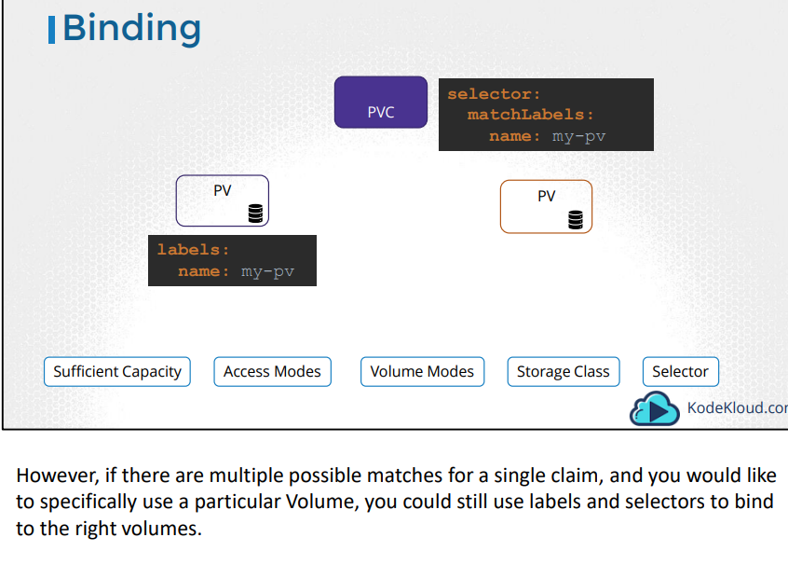
* Finally, note that a smaller Claim may get bound to a larger volume if all the other criteria matches and there are no better options
* There is a one-to-one relationship between Claims and Volumes, so no other claim can utilize the remaining capacity in the volume
* If there are no volumes available the Persistent Volume Claim will remain in a pending state, until newer volumes are made available to the cluster
* Once newer volumes are available the claim would automatically be bound to the newly available volume.
* 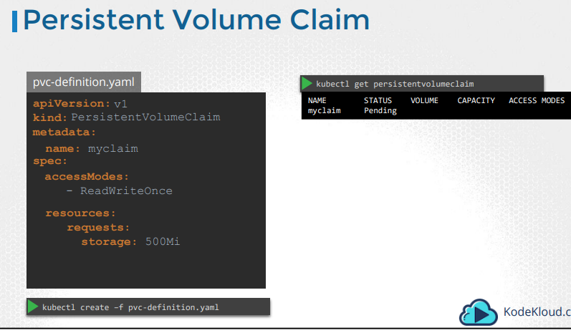
* Let us now create a Persistent Volume Claim. We start with a blank template. Set the apiVersion to v1 and kind to PersistentVolumeClaim. We will name it myclaim. Under specification set the accessModes to ReadWriteOnce. And set resources to request a storage of 500 mega bytes. Create the claim using kubectl create command.
* To view the created claim run the kubectl get persistentvolumeclaim command. We see the claim in a pending state
* 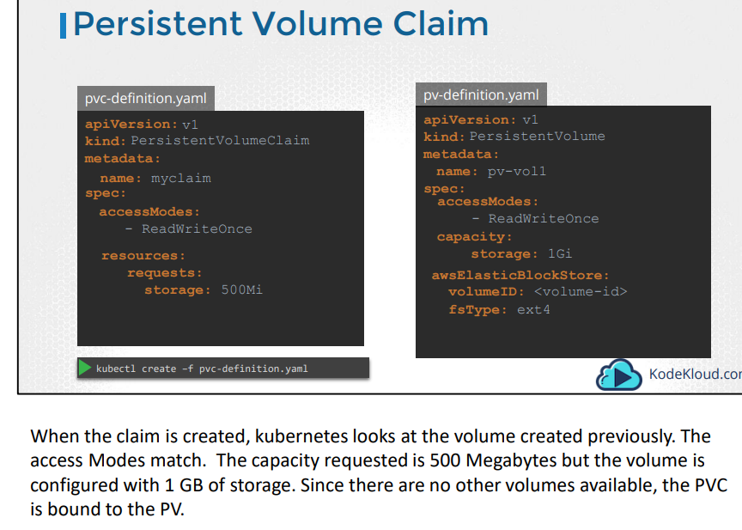
* 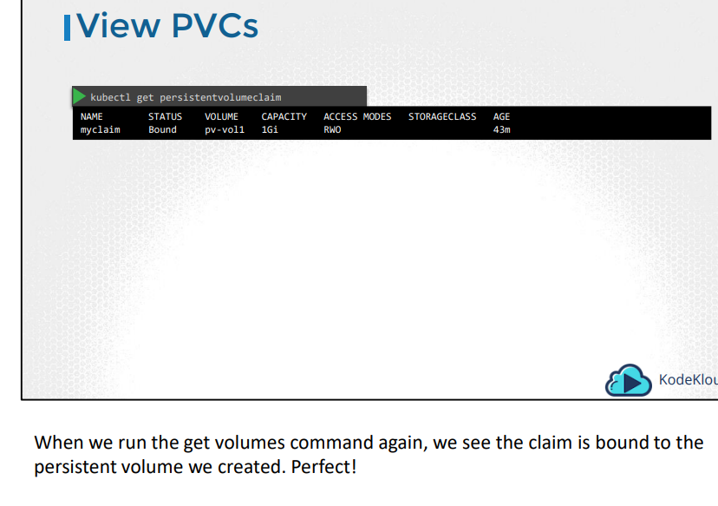
* To delete a PVC run the kubectl delete persistentvolumeclaim command. But happens to the Underlying Persistent Volume when the claim is deleted? You can chose what is to happen to the volume. By default, it is set to Retain. Meaning the Persistent Volume will remain until it is manually deleted by the administrator Or it can be Deleted automatically
* This way as soon as the claim is deleted, the volume will be deleted as well. Or a third option is to recycle. In this case the data in the volume will be scrubbed before making it available to other claims
* 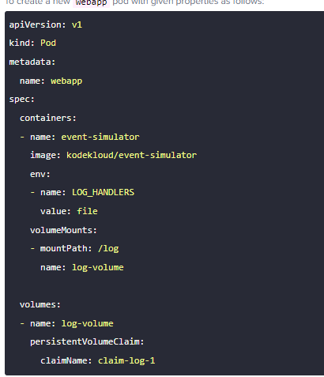

Storage Classes:

* In the previous lectures, we discussed about how to create PVs and then create PVCs to claim that storage and then use the PVCs in the pod definition files as volumes.
* 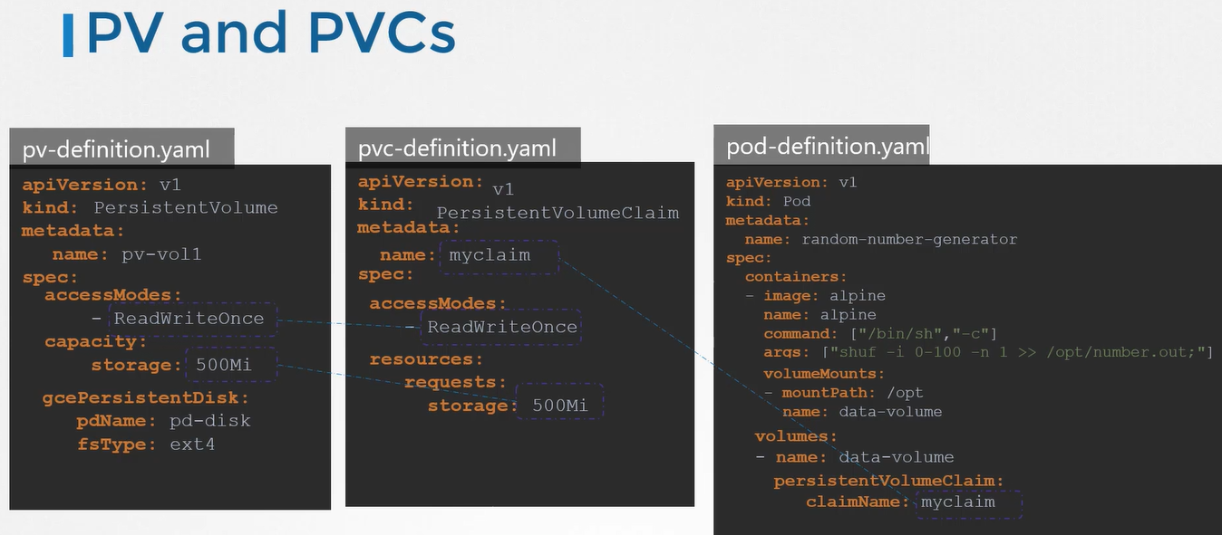
* In this case, we create a PVC from a Google Cloud persistent disk, The problem here is that before this PV is created you must have created the disk on Google Cloud
* 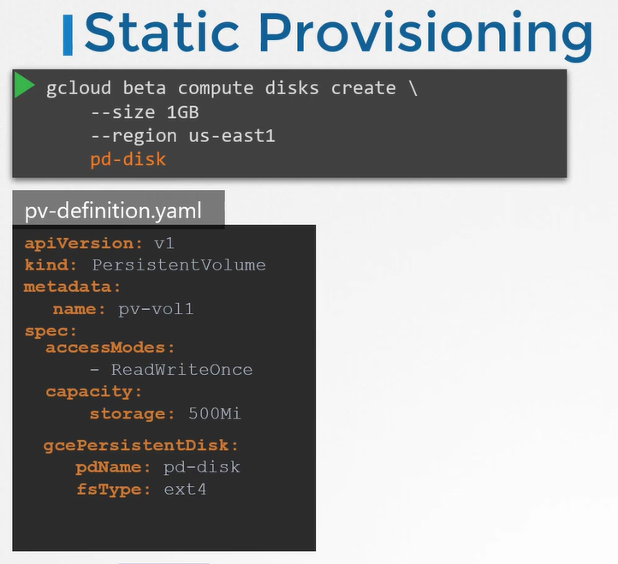
* Every time an application requires storage,you have to first manually provision the disk on Google Cloud and then manually create a persistent
* volume definition file using the same name as that of the disc that you created That's called static provisioning volumes.
* 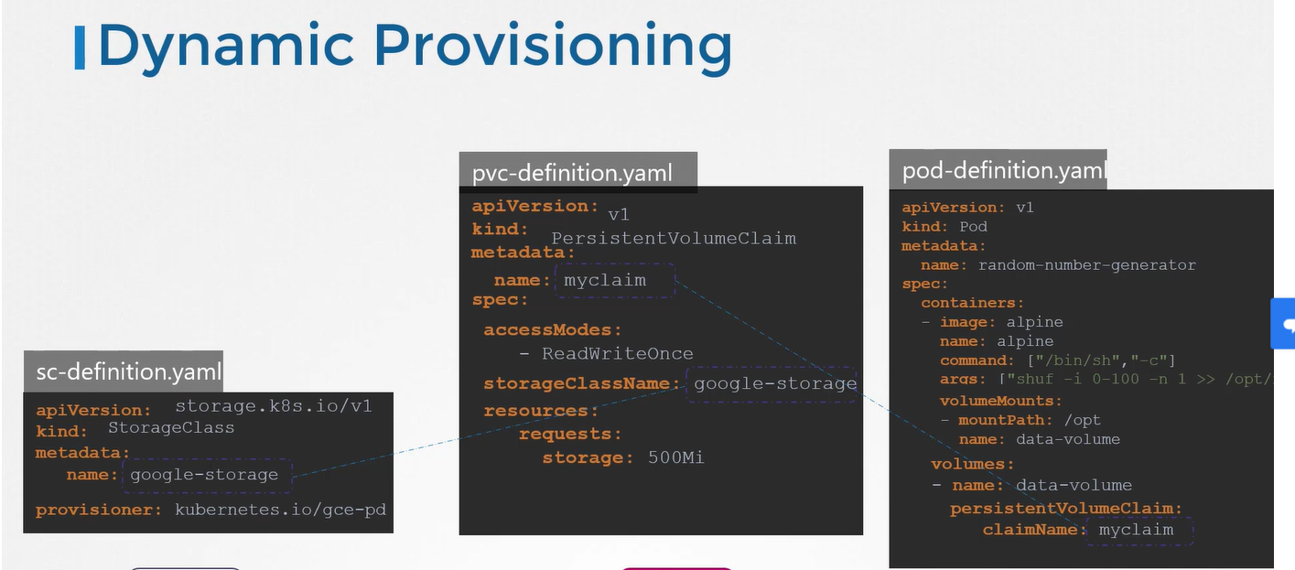

kind: StorageClass

apiVersion: storage.k8s.io/v1

metadata:

name: local-storage

provisioner: kubernetes.io/no-provisioner

volumeBindingMode: WaitForFirstConsumer

--------

apiVersion: v1

kind: PersistentVolume

metadata:

name: demo-pv

labels:

type: local

spec:

capacity:

storage: 2Gi

volumeMode: Filesystem

accessModes:

- ReadWriteOnce

storageClassName: local-storage

hostPath:

path: "/Users/atul/Documents/Dummy/k8s_testing/logs"

-----------

kind: PersistentVolumeClaim

apiVersion: v1

metadata:

name: demo-pvclaim

spec:

accessModes:

- ReadWriteOnce

storageClassName: local-storage

resources:

requests:

storage: 1Gi

apiVersion: v1

kind: Pod

metadata:

name: task-pv-pod

spec:

containers:

- name: pv-pod

image: nginx

ports:

- containerPort: 80

volumeMounts:

- name: pv-vol

mountPath: "/usr/share/nginx/html"

volumes:

- name: pv-vol

persistentVolumeClaim:

claimName: demo-pvclaim

* It would have been nice if the volume gets provisioned automatically when the application requires it. That's where storage classes come in.
* With storage classes, you can define a provisioner such as Google storage that can automatically provision storage on Google Cloud and attach that to pods
* when a claim is made That's called dynamic provisioning of volumes
* You do that by creating a storage class object with the API version set to storage.case.io/v1 Specify a name and use provisioner as
* kubernetes.io/gce-pd. Going back to our original state, where we have a pod using a PVC for its storage, and the PVC is bound to a PV, We no longer need the PV definition because the PV and any associated storage is going to be created automatically when the storage class is created.
* For the PVC to use the storage class we defined, we specify the storage class name in the PVC definition. That's how the PVC knows which storage class to use.

Stateful Sets:

* Why StatefulSets:
* To summarize, we want the master to come up first and then the slaves. We want to clone data from master to slave 1 first, and then enable replication from master to slave 1, and then wait for slave 1 to be ready, and then clone data from slave 1 to slave 2, and then enable continuous replication from master to slave 2, and make sure that the slaves are configured with the address of the master node. This is the high-level plan for deploying MySQL Cluster.
* 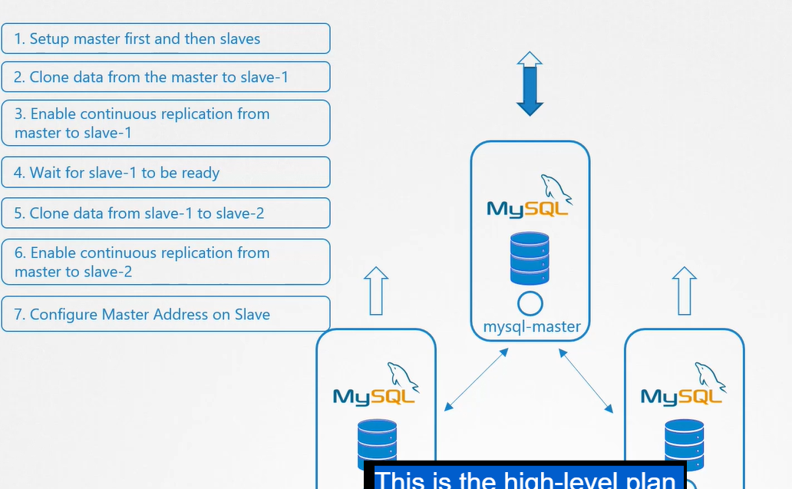
* 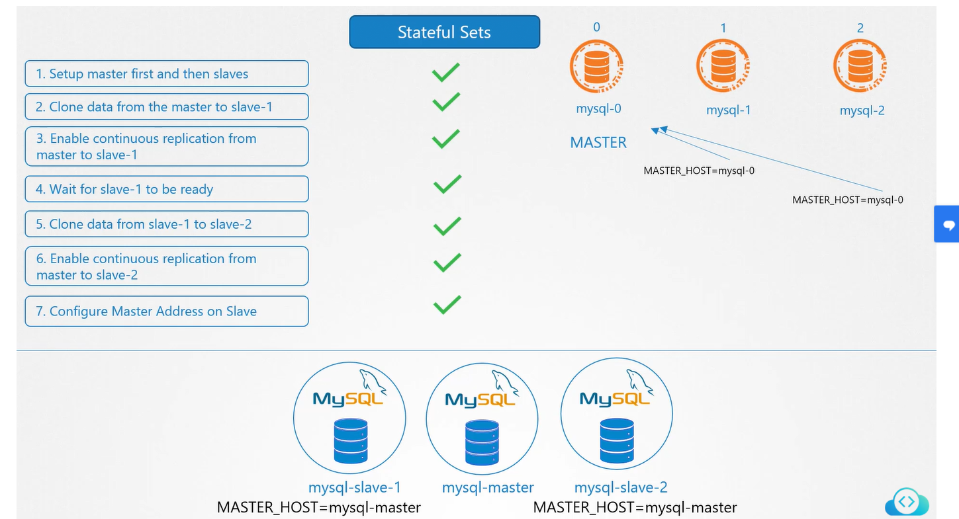
* In the Kubernetes world, we have learned so far that such kind of a deployment in each of these instances, including the master and slaves, are a pod part of a deployment. That way, we can easily scale it up or down as required. In step one, we want the master to come up first and then the slaves. In case of the slaves, we want slave 1 to come up first, perform an initial clone of data from the master. In step four, as you can see, we want slave 2 to come up next and clone data from slave 1. Now, with deployments, you can't guarantee that order. With deployments, all pods part of the deployment come up at the same time. The first step can't be implemented with a deployment. In the following steps, while cloning data from master to slave 1, or slave 1 to slave 2, or while enabling continuous replication on the slaves in steps two, three, five, six, and seven, we must be able to differentiate the master and slave pods from each other.
* We want to designate one of these pods as master and others as slave. We need the master to have a constant host name or address, one that does not change. We cannot rely on the IP address, as we know by now that IP addresses of pods are dynamically assigned, and they may change when the pod gets recreated. We definitely need a static host name. As we have seen while working with deployments, the pods come up with random names, Even if we decide to designate one of
* these pods as the master and use its name to configure the slaves, if that pod crashes and the deployment creates a new pod in its place, it's going to come up
* with a totally new pod name. Now, the slaves are pointing to an address that does not exist. Because of all of these, the remaining steps can't be executed. That's where StatefulSets come in.
* StatefulSets are similar to deployment sets as in they create pods based on a template They can scale up and scale down. They can perform rolling updates and rollbacks, but there are some differences. With StatefulSets, pods are created in a sequential order. After the first pod is deployed, it must be in a running and ready state before the next pod is deployed. That helps us ensure that the master is deployed first, then slave 1 and slave 2 That helps us with steps one and four.
* StatefulSets assign a unique ordinal index to each pod in numbers starting from zero for the first pod and increments by one. Each pod gets a unique name derived from this index combined with the StatefulSet name. The first pod gets mysql-0, the second gets mysql-1, the third gets mysql-2, et cetera. No more random names. You can rely on these names going forward. You can be sure that the first pod in any StatefulSet is always going to be the name of the StatefulSet followed by -0. You can always use that as the master in any setup. The pod mysql-2 knows that it has to perform an initial clone of data from the pod mysql-1. Say, if you were to scale up the deployment by deploying another pod, mysql-3, for instance, then it would know that it can perform a clone from mysql-2. To enable continuous replication, you can now point the slaves to the master at mysql-0. Even if the master fails and the pod is recreated, it would still come up with the same name.
* StatefulSets maintain a sticky identity for each of their pods, and these help with the remaining steps. The master is now always the master and available at the address mysql-0, and that is why you need StatefulSets.
* 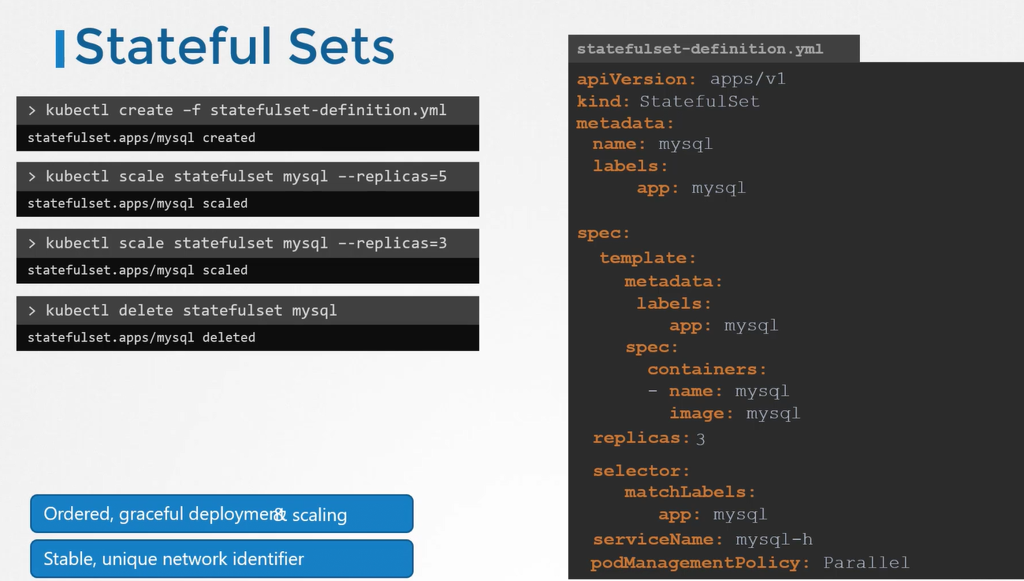
* If the instances need to come up in a particular order, if the instances need a stable name, et cetera. Once you evaluate your requirements and decide that StatefulSet is the right choice for you, you can create a StatefulSet, just like how you created a Deployment.
* Template is same as deployment and then all you need to do is change the kind to StatefulSet instead of Deployment. Apart from that, a StatefulSet also requires a service name specified. You must specify the name of a headless service. We will discuss about headless service later
* it creates Pods one after the other, that's ordered graceful deployment. Each Pod gets a stable, unique DNS record on the network that any other application can use to access a Pod. When you scale the StatefulSet, it scales in an ordered, graceful fashion where each Pod comes up, becomes ready and only then the next one comes up. This helps when you want to scale MySQL databases, as each new instance can clone from the previous instance.
* It works in the reverse order when you scale it down. The last instance is removed first followed by the second last one. When you delete a StatefulSet, the Pods are deleted in the reverse order. but you can override that behavior to cause StatefulSet to not follow an ordered launch

HEADLESS SERVICES:

* In the previous lecture, we said that when you create a StatefulSet, it deploys one part at a time gets an ordinal index, and that each pod has a stable unique name, which is MySQL zero, one and two. We can point the slaves to reach the master at MySQL-0 but there is something missing here.
* From what we know about services and DNS specifically in Kubernetes the way you point one application within the cluster to another application is through a service. If we had a web server then to make the database server accessible to the web server, we create a service for the database. We name it "MySQL." The service, as we know, acts as a load-balancer, the traffic coming into the service is balanced across all the pods in the deployment.
* The service has a cluster IP and the DNS name associated with it which usually goes like MySQL.default.service.cluster.local. Any other application within
* the environment, like a web server, for instance, can now use this DNS name to reach the MySQL database. Now remember, in the previous lecture, we said that, since this is a master slave topology the reads could be served by master or slaves, but the rights must only be processed by the master. It is okay for the web server to read from the MySQL service but you can't write to that service as it's going to load-balance the rights to all parts under the service and that's not what we want for our MySQL cluster.
* You want to point the web server to the master database server only but how do you do that? What's one way to reach the master pod directly. If you know
* the IP address of the master pod you can configure that in the web server but as we know, IP addresses are dynamic
* What we need is a service that does not load-balance requests but gives us a DNS entry to reach each pod and that's what a headless service is
* A headless service is created like a normal service, but it does not have an IP of its own like a cluster IP for a normal service. It does not perform
* any load-balancing. All it does is create DNS entries for each pod using the pod name and a subdomain.
* When you create a headless service say with the name MySQL-H, each pod gets a DNS record created in the form pod name
* dot the name of the headless service dot name space followed by the cluster domain. In this case, each pod gets pod name dot headless service which happens to be the MySQL-0. MySQL-H.default.service.cluster.local The web application can now point to the DNS entry for the master, MySQL server@mysqlzero. MySQLH.default.SVC.cluster.local and that should always work.
* To create a headless service,
* create a service definition file
* 